CSS ISLAMIC STUDIES · T5KB
بِسۡمِ ٱللَّهِ ٱلرَّحۡمَٰنِ ٱلرَّحِيمِ
Topic V — Islamic Civilization and Culture
The Knowledge Base · Meanings and elements of civilization, its role in personality and community, and the eight characteristics: Tawhid, self-purification, dignity, equality, social justice, moral values, tolerance and rule of law
Eleven chapters built from the syllabus and from the nine questions set on this topic between 2016 and 2025, with the contemporary debates, the examiner's record, five likely questions, a numbered one-liner bank and section-by-section revision notes. Every point carries its evidence — the Quran first, then the Hadith, then history and the scholars — inside the point itself.
Edition of September 2026 · covers the papers of 2015–2026 · written for CSS 2027 and after
Contents
HOW TO BUILD THE CONTENTS
The Contents below is left empty on purpose. In Microsoft Word, right-click anywhere on the grey line below and choose Update Field → Update entire table → OK. The full table of contents with page numbers will appear.
On a Mac: right-click (or Control-click) the line → Update Field. If you edit the notes later, repeat this step to refresh the page numbers. You can also press Ctrl + A then F9 (Windows) to update every field in the document at once.

How to Use This Document 8
What this topic covers 8
How this document is built 9
Part Zero — The ABC Before the Chapters 10
0.1 The words of this topic 10
0.2 The tree of Islamic civilization 11
Chapter 1 · Culture and Civilization: Meanings and Vital Elements 12
1.1 The meaning of culture 12
(1) The words 12
(2) The definitions 12
1.2 The meaning of civilization 12
(1) The words 12
(2) The definitions 12
(3) The name 'Madinah' 13
1.3 Culture and civilization — the difference 13
1.4 The vital elements of a civilization 13
1.5 The Islamic view of civilization 14
1.6 The characteristics of Islamic culture and civilization (2016, 2018) 15
Chapter 2 · The Role of Civilization in Building the Personality and the Community 16
2.1 How civilization shapes the personality 16
(1) Identity 16
(2) Values and conscience 16
(3) Discipline and habits 16
(4) Purpose and balance 16
(5) The ideal personality — Iqbal's Mard-e-Momin 16
2.2 How civilization shapes the community 17
(1) Unity and brotherhood 17
(2) Institutions 17
(3) Law and order 17
(4) Welfare 17
(5) Shared culture and memory 17
2.3 The historical proof — what Islamic civilization gave the world 17
2.4 The Quaid on Muslim culture 18
Chapter 3 · Tawhid: The Foundation of Islamic Civilization 19
3.1 Tawhid — the meaning 19
3.2 How Tawhid builds a civilization 19
(1) One God → one humanity 19
(2) Freedom from all false masters 19
(3) Unity of knowledge and life 20
(4) Freedom for science 20
(5) Accountability and morality 20
(6) Unity of the Ummah 20
(7) Tawhid in art and architecture 21
Chapter 4 · Tazkiyah and Ihsan: Self-Purification 22
4.1 The meaning of Tazkiyah 22
(1) Literal meaning 22
(2) Technical meaning 22
4.2 Tazkiyah in the Quran 22
(1) Success depends on it 22
(2) A purpose of the Prophethood 23
(3) The sound heart on the Last Day 23
(4) Restraining desire 23
(5) The three stages of the self 24
4.3 Tazkiyah in the Sunnah 24
4.4 Ihsan — the highest level of faith 25
4.5 The means of Tazkiyah 25
4.6 The diseases and the virtues of the heart 26
(1) The diseases (muhlikat — the destroyers) 26
(2) The virtues (munjiyat — the saviours) 26
4.7 The individual impacts of Tazkiyah 26
4.8 The collective impacts — self-purification and the evolution of society (2024) 27
(1) The Quranic law of social change 27
(2) The impacts on society 27
(3) The historical proof 28
(4) The evolution of society 28
Chapter 5 · Sufism: Its Role and Its Reform 29
5.1 The meaning of Sufism 29
(1) The word 29
(2) The concept 29
5.2 The early masters 29
5.3 The Sufis and the spread of Islam in the subcontinent 30
(1) The main orders (silsilahs) 30
(2) How the Sufis spread Islam 30
(3) The Sufis as reformers 31
5.4 The present deviations 31
5.5 Is the reform of today's deviations possible through Sufism? 32
Yes — if Sufism returns to its own foundations 32
The conditions 32
Chapter 6 · The Dignity of Man 33
6.1 Dignity as a civilizational principle 33
6.2 How dignity shaped the civilization 33
Chapter 7 · Equality and the Classist Lifestyle 34
7.1 What is a 'classist lifestyle'? 34
7.2 Equality in Islam 34
7.3 Difference in wealth is a test, not a rank 35
7.4 The status of the classist lifestyle in Islam 35
(1) Pride and arrogance — condemned 35
(2) Competition in wealth and display — condemned 36
(3) Extravagance — condemned 36
(4) Contempt for the poor — condemned 37
(5) The Islamic alternative — contentment and looking below 37
(6) The example of Qarun 38
(7) The Prophetic and Rashidun lifestyle 38
7.5 The effects of the classist lifestyle on human society 38
7.6 The Islamic remedy 39
Chapter 8 · Social Justice 40
8.1 The pillars 40
Chapter 9 · The Moral Value System of Islam 41
9.1 Morality at the heart of the mission 41
9.2 The sources of Islamic morality 41
9.3 The features of the moral system 41
9.4 The moral code of the Quran — Surah Al-Isra (17:23–37) 41
9.5 The core moral values 42
(1) Truthfulness (sidq) 42
(2) Trustworthiness (amanah) 43
(3) Justice ('adl) 43
(4) Keeping promises 43
(5) Modesty and chastity (haya') 43
(6) Humility, patience, forgiveness, generosity 44
(7) Social morals 44
9.6 Islamic morality and secular ethics 44
9.7 Morality as the life of civilization 44
Chapter 10 · Tolerance — in the Prophetic Age and in Muslim History 46
10.1 The meaning 46
10.2 The Quranic and Prophetic foundation 46
10.3 Tolerance in post-Prophetic Muslim history 47
(1) The Rightly-Guided Caliphs 47
(2) The Umayyads and the conquest of Sindh 48
(3) The Abbasids — Baghdad 48
(4) Muslim Spain — Cordoba (929–1031) 48
(5) Salahuddin and Jerusalem (1187) 48
(6) The Ottomans 48
(7) Muslim rule in the subcontinent 48
(8) Pakistan 48
10.4 Honest limits 49
Chapter 11 · The Rule of Law 50
11.1 The meaning 50
11.2 The Quranic basis 50
11.3 The Prophetic example 51
11.4 The Rightly-Guided Caliphs — rulers under law 51
11.5 Institutions of the rule of law in Muslim history 52
11.6 Rule of law in Pakistan 52
Part Two — Contemporary Challenges, Narratives and Hot Debates 53
12.1 Materialism, consumerism and status competition 53
12.2 Moral decline, corruption and the loss of trust 53
12.3 Sufism: true teaching and the deviations of shrine culture 53
12.4 Digital ethics — social media, privacy, backbiting and fake news 53
12.5 Tolerance in a polarised society 53
Part Three — The Examiner's Record and Five Likely Questions 54
13.1 Every question on this topic, 2016–2025 54
13.2 What the record teaches 54
13.3 Five likely questions 54
Part Four — The One-Liner Bank 55
One-liners · Culture and civilization 55
One-liners · Tawhid 55
One-liners · Tazkiyah and Ihsan 55
One-liners · Sufism 56
One-liners · Dignity, equality and social justice 56
One-liners · Moral values 57
One-liners · Tolerance 57
One-liners · Rule of law 57
Part Five — Revision Notes · Topic 5 59
R5.0 The whole topic in one picture 59
R5.1 Chapter 1 · Culture and civilization: meanings and elements 59
1.1–1.2 The meanings 59
1.3 The difference 59
1.4 The vital elements (draw the wheel) 59
1.5 The Islamic view 59
1.6 The characteristics (the 2016 and 2018 list) 60
R5.2 Chapter 2 · Role of civilization in personality and community 60
2.1 Personality 60
2.2 Community 60
2.3 Gifts to the world (names to drop) 60
2.4 The Quaid 60
R5.3 Chapter 3 · Tawhid — the foundation 60
R5.4 Chapter 4 · Tazkiyah and Ihsan (2017, 2018, 2024) 61
4.1 Meaning 61
4.2 Quran — five proofs 61
4.3 Sunnah — three hadith 61
4.4 Ihsan 61
4.5 The means (nine) 61
4.6 Diseases and virtues 61
4.7 Individual impacts 62
4.8 Collective impacts and the evolution of society (draw the ripple) 62
R5.5 Chapter 5 · Sufism (2021) 62
5.1 Meaning 62
5.2 Early masters 62
5.3 The subcontinent (draw the timeline) 62
5.4 Deviations 62
5.5 Reform through Sufism — yes, if… 62
R5.6 Chapter 6 · Dignity of man 63
R5.7 Chapter 7 · Equality and the classist lifestyle (2025) 63
7.1 Define 63
7.2 Equality 63
7.3 Wealth is a test, not a rank 63
7.4 Status in Islam — condemned on six counts 63
7.5 Effects on society (nine) 63
7.6 Remedy 63
R5.8 Chapter 8 · Social justice 64
R5.9 Chapter 9 · The moral value system (2019) 64
9.1–9.2 Basis and sources 64
9.3 Eight features 64
9.4 The code of Al-Isra (23–37) — eleven commands 64
9.5 Core values 64
9.6 Versus secular ethics 64
9.7 Morality and the life of civilizations 64
R5.10 Chapter 10 · Tolerance in Muslim history (2025) 64
R5.11 Chapter 11 · Rule of law 65
R5.12 Part Two · Today 65
R5.13 The figures to draw in the paper 65

How to Use This Document

What this topic covers
Topic 5 carries the syllabus head 'Islamic Civilization and Culture': the meanings and vital elements of civilization, its role in the development of personality and community, and the eight characteristics of Islamic civilization named in the syllabus — Tawhid, self-purification, dignity of man, equality, social justice, moral values, tolerance and rule of law.
Syllabus line / past question | Where it is taught
Meaning of culture and civilization; characteristics of Islamic culture (2016, 2018) | Chapter 1
Role of civilization in personality and community (never asked) | Chapter 2
Tawhid as the foundation | Chapter 3
Self-purification and Ihsan (2017, 2018, 2024) | Chapter 4
Sufism and the spread of Islam; reform of deviations (2021) | Chapter 5
Dignity of man | Chapter 6 (with Topic 4)
Equality and the classist lifestyle (2025) | Chapter 7
Social justice | Chapter 8 (with Topic 4)
Moral value system (2019) | Chapter 9
Tolerance in post-Prophetic history (2025) | Chapter 10
Rule of law (never asked) | Chapter 11

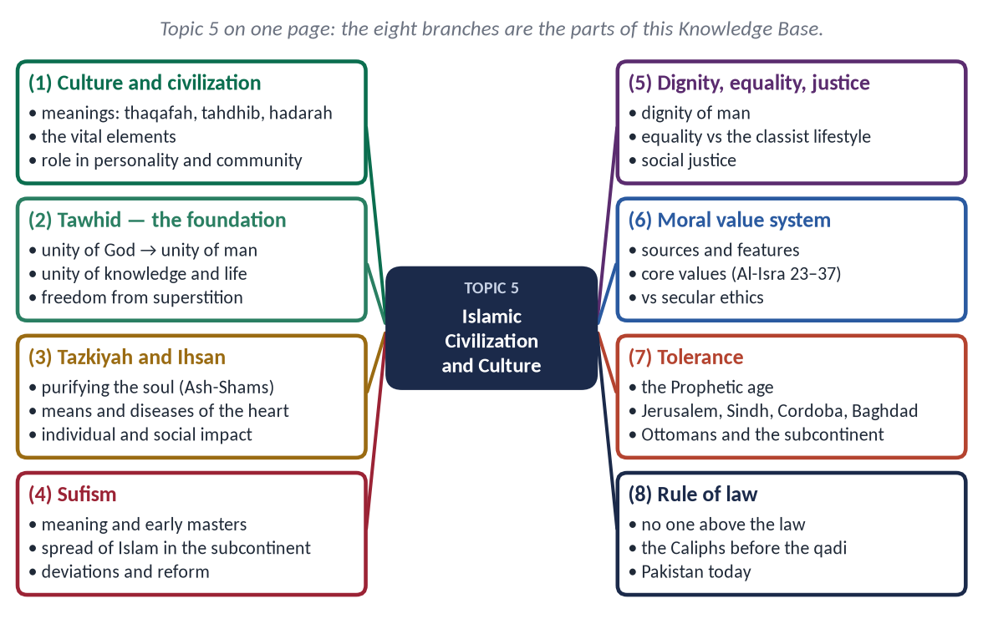
Figure 1 · Topic 5 on one page. The eight branches are the parts of this Knowledge Base.

How this document is built
1. Part Zero — the ABC: the words of the topic and the tree of Islamic civilization.
2. Part One — eleven chapters; in every point the evidence comes Quran → Hadith → Companions and history → scholars.
3. At-a-glance charts after long sections — the names only.
4. Part Two — contemporary challenges and hot debates.
5. Part Three — the examiner's record and five likely questions.
6. Part Four — the numbered one-liner bank.
7. Part Five — chapter-by-chapter revision notes.
EXAMINER'S EYE · THIS TOPIC IN THE PAPER
Self-purification is the favourite — 2017, 2018 (with Ihsan) and 2024, with Sufism in 2021. Characteristics of Islamic culture or civilization came in 2016 and 2018, moral values in 2019. Since 2025 the examiner has begun to set the individual characteristics as full questions — equality (as 'the classist lifestyle') and tolerance (in post-Prophetic history). Rule of law and personality and community are the gaps.

Part Zero — The ABC Before the Chapters

0.1 The words of this topic
Term | Arabic / Urdu | Meaning in this topic
Thaqafah | ثَقَافَة | Culture; literally 'straightening, refining' (as a spear is straightened).
Tahdhib / Tehzeeb | تَهْذِيب | Culture, refinement; literally 'pruning' a tree.
Hadarah | حَضَارَة | Civilization; settled urban life (opposite of badawah, desert life).
Tamaddun | تَمَدُّن | Civilization; from madinah, city.
'Umran | عُمْرَان | Ibn Khaldun's word for human civilization and social organisation.
Tawhid | تَوْحِيد | The oneness of Allah — the root of the civilization.
Tazkiyah | تَزْكِيَة | Self-purification; also growth.
Ihsan | إِحْسَان | Excellence: worshipping Allah as though you see Him.
Nafs | نَفْس | The self, the soul with its desires.
Tasawwuf | تَصَوُّف | Sufism: the discipline of the heart.
Muhasabah | مُحَاسَبَة | Taking account of oneself.
Akhlaq | أَخْلَاق | Morals, character.
Musawat | مُسَاوَاة | Equality.
Tabaqati tafriq | طَبَقَاتِي تَفْرِيق | Class division — the classist lifestyle.
Tasamuh / Rawadari | تَسَامُح | Tolerance (Urdu rawadari).
Siyadat al-Qanun | سِيَادَةُ الْقَانُون | Rule of law.

0.2 The tree of Islamic civilization
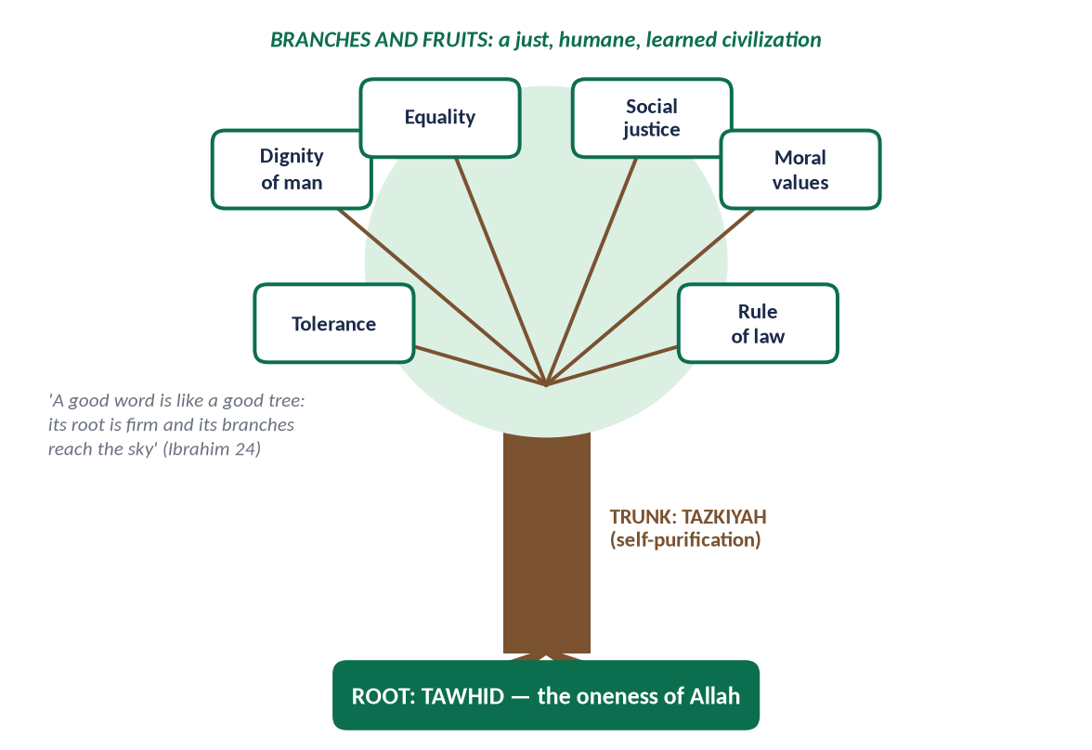
Figure 2 · The eight characteristics of the syllabus as one tree: Tawhid the root, Tazkiyah the trunk, the other six the branches.
✦ QURAN
﴿… كَلِمَةٗ طَيِّبَةٗ كَشَجَرَةٖ طَيِّبَةٍ أَصۡلُهَا ثَابِتٞ وَفَرۡعُهَا فِي ٱلسَّمَآءِ ۝ تُؤۡتِيٓ أُكُلَهَا كُلَّ حِينِۭ بِإِذۡنِ رَبِّهَاۗ …﴾
“A good word is like a good tree, whose root is firm and whose branches reach the sky; it gives its fruit at every time by the permission of its Lord.” (Ibrahim, Quran)
➜ 'A good word is like a good tree, whose root is firm and whose branches reach the sky; it gives its fruit at every time by the permission of its Lord.'

Learn the characteristics as a tree, not a list: Tawhid is the root from which everything grows; Tazkiyah is the trunk that carries it into human character; dignity, equality, justice, moral values, tolerance and rule of law are the branches that shelter society.

Chapter 1 · Culture and Civilization: Meanings and Vital Elements
Asked in 2016: 'What is meant by culture and civilization? Describe the characteristics of Islamic culture.'

1.1 The meaning of culture

(1) The words
- English 'culture' comes from Latin cultura — cultivation of the soil; then cultivation of the mind.
- Arabic thaqafah (ثَقَافَة) — refining and straightening; Urdu tehzeeb (تہذیب) — pruning a tree so that it grows well.

(2) The definitions
✦ SCHOLARLY VIEW
E. B. Tylor · Primitive Culture (1871)
“Culture … is that complex whole which includes knowledge, belief, art, morals, law, custom, and any other capabilities and habits acquired by man as a member of society.”
➜ The classic definition — note that belief and morals come first.

In simple words: culture is the way of life of a people — their beliefs, values, language, customs, arts and manners.

1.2 The meaning of civilization

(1) The words
- English 'civilization' comes from Latin civis (citizen) and civitas (city).
- Arabic hadarah (حَضَارَة) — settled, urban life; tamaddun (تَمَدُّن) — from madinah, the city.

(2) The definitions
✦ SCHOLARLY VIEW
Will Durant · The Story of Civilization, Vol. I (1935)
“Civilization is social order promoting cultural creation. Four elements constitute it: economic provision, political organization, moral traditions, and the pursuit of knowledge and the arts.”
➜ A four-element definition for the introduction.

✦ SCHOLARLY VIEW
Ibn Khaldun · Al-Muqaddimah (1377)
Ibn Khaldun called human society 'umran (عُمْرَان) and traced its growth from desert life (badawah) to settled city life (hadarah), held together by group solidarity ('asabiyyah); he warned that luxury and moral decay destroy a civilization within a few generations.
➜ The Muslim founder of sociology on civilization.

(3) The name 'Madinah'
The Prophet ﷺ renamed Yathrib as Madinah — 'the city' — the place where the Islamic civilization (tamaddun) began.

1.3 Culture and civilization — the difference
Point | Culture | Civilization
Nature | Inner: beliefs, values, manners | Outer: institutions, cities, sciences, technology
Question it answers | What we are | What we have
Transfer | Hard to borrow; tied to faith and identity | Easy to borrow (technology, systems)
Change | Slow | Fast
Example | Modesty, hospitality, respect for elders | Roads, universities, courts, hospitals

In Islam the two are one: the inner culture (faith and morals) produces the outer civilization (institutions and knowledge). Iqbal warned against borrowing Western civilization's technology while losing Islam's culture.

1.4 The vital elements of a civilization
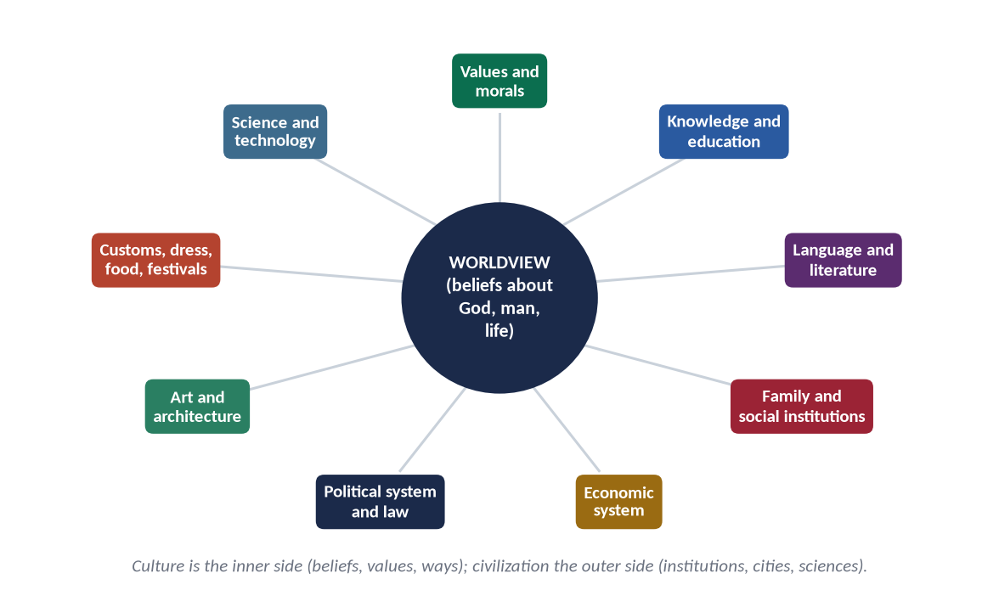
Figure 3 · The vital elements of any civilization, around its worldview.
Element | What it provides
Worldview and beliefs | Answers about God, man, life and death — the root of all else
Values and morals | Standards of right and wrong
Knowledge and education | Science, philosophy, schools
Language and literature | Means of thought and communication
Family and social institutions | Continuity of values across generations
Economic system | Production and distribution of wealth
Political system and law | Order, justice, authority
Art and architecture | Expression of beauty and identity
Customs, dress, food, festivals | Daily forms of the culture
Science and technology | Mastery of nature

1.5 The Islamic view of civilization
✦ QURAN
﴿… إِنِّي جَاعِلٞ فِي ٱلۡأَرۡضِ خَلِيفَةٗۖ …﴾
“Indeed, I will make upon the earth a vicegerent (khalifah).” (Al-Baqarah, Quran)
➜ Man is Allah's vicegerent on earth — civilization is building the earth as a trust.

✦ QURAN
﴿… هُوَ أَنشَأَكُم مِّنَ ٱلۡأَرۡضِ وَٱسۡتَعۡمَرَكُمۡ فِيهَا …﴾
“He produced you from the earth and settled you in it (to develop it).” (Hud, Quran)
➜ 'He produced you from the earth and settled you in it (ista'marakum)' — the Quranic word for developing the earth.

✦ QURAN
﴿وَٱبۡتَغِ فِيمَآ ءَاتَىٰكَ ٱللَّهُ ٱلدَّارَ ٱلۡأٓخِرَةَۖ وَلَا تَنسَ نَصِيبَكَ مِنَ ٱلدُّنۡيَاۖ وَأَحۡسِن كَمَآ أَحۡسَنَ ٱللَّهُ إِلَيۡكَۖ وَلَا تَبۡغِ ٱلۡفَسَادَ فِي ٱلۡأَرۡضِۖ …﴾
“Seek, through what Allah has given you, the home of the Hereafter, and do not forget your share of this world; do good as Allah has done good to you, and do not seek corruption in the land.” (Al-Qasas, Quran)
➜ Seek the Hereafter without forgetting your share of this world; do good; do not spread corruption — the balance of Islamic civilization.

1.6 The characteristics of Islamic culture and civilization (2016, 2018)
Characteristic | Meaning (chapter)
Tawhid | One God → one humanity, unity of knowledge and life (Ch. 3)
Prophethood (Risalah) | The Prophet ﷺ as the model of culture (Topic 3)
Accountability (Akhirah) | Every act answerable — the inner police
Self-purification | Character before comfort (Ch. 4)
Dignity of man | Honoured children of Adam (Ch. 6)
Equality | No race or class superiority (Ch. 7)
Social justice | Wealth circulates; the weak protected (Ch. 8)
Moral values | Truth, trust, modesty, justice (Ch. 9)
Tolerance | No compulsion; minorities protected (Ch. 10)
Rule of law | No one above the law (Ch. 11)
Knowledge | 'Read!' — the first word (Al-Alaq)
Balance (wasatiyyah) | Neither monasticism nor materialism (Al-Baqarah 143)
Universality | For all mankind; absorbed Arab, Persian, Turkish, Indian cultures
Brotherhood | 'The believers are brothers' (Al-Hujurat 10)
Cleanliness and simplicity | 'Purity is half of faith' (Muslim)
Family | The basic unit of the culture (Topic 4)
Dignity of labour | Earning by one's own hands (Al-Bukhari)
Art and architecture | Calligraphy, geometry, mosques — beauty without idols

✦ SCHOLARLY VIEW
Dr Mustafa al-Siba'i · Min Rawa'i Hadaratina (Urdu: Islami Tehzeeb kay Chund Darakhshan Pehloo — on the FPSC reading list)
Siba'i shows that Islamic civilization was built on pure monotheism, had a universal human aim, made morality the basis of every field of life, honoured knowledge, and practised a religious tolerance unknown to other civilizations of its age.
➜ A ready-made list from the reading list.

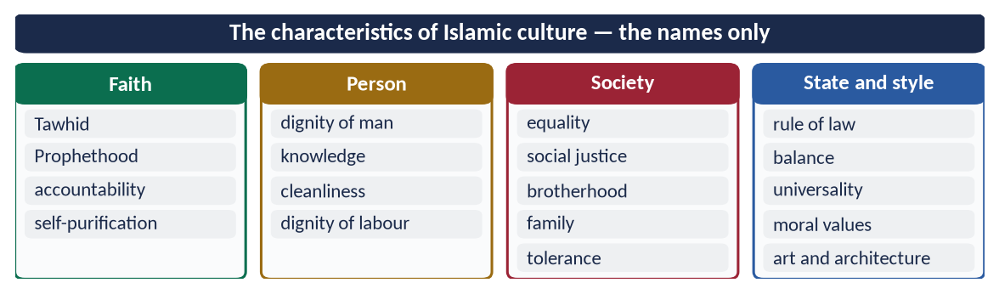
Figure 4 · At a glance — the characteristics of Islamic culture — the names only. The detail is in the sections above.

Chapter 2 · The Role of Civilization in Building the Personality and the Community
In the syllabus, never asked — a likely question.

2.1 How civilization shapes the personality

(1) Identity
Culture answers 'Who am I?' — a Muslim, a servant of Allah, a member of the Ummah.

(2) Values and conscience
It builds the inner judge that says 'this is right, that is wrong'.
✦ HADITH
الْبِرُّ حُسْنُ الْخُلُقِ، وَالْإِثْمُ مَا حَاكَ فِي صَدْرِكَ، وَكَرِهْتَ أَنْ يَطَّلِعَ عَلَيْهِ النَّاسُ
“Righteousness is good character, and sin is what wavers in your heart and you dislike people to know of it.” (Muslim)
➜ Culture shapes the conscience.

(3) Discipline and habits
Five daily prayers, fasting, cleanliness and the etiquettes (adab) of eating, greeting and speaking train a disciplined personality.

(4) Purpose and balance
✦ QURAN
﴿وَمَا خَلَقۡتُ ٱلۡجِنَّ وَٱلۡإِنسَ إِلَّا لِيَعۡبُدُونِ﴾
“And I did not create the jinn and mankind except to worship Me.” (Adh-Dhariyat, Quran)
➜ Man was created to worship Allah — a life with purpose.

(5) The ideal personality — Iqbal's Mard-e-Momin
✦ SCHOLARLY VIEW
Allama Muhammad Iqbal · Bal-e-Jibril; Zarb-e-Kalim
Iqbal's mard-e-momin (the man of faith) combines faith, knowledge, courage, humility and action — the personality that Islamic culture aims to produce.
➜ The goal of Islamic education.

2.2 How civilization shapes the community

(1) Unity and brotherhood
✦ QURAN
﴿إِنَّمَا ٱلۡمُؤۡمِنُونَ إِخۡوَةٞ فَأَصۡلِحُواْ بَيۡنَ أَخَوَيۡكُمۡۚ وَٱتَّقُواْ ٱللَّهَ لَعَلَّكُمۡ تُرۡحَمُونَ﴾
“The believers are but brothers, so make settlement between your brothers. And fear Allah that you may receive mercy.” (Al-Hujurat, Quran)
➜ 'The believers are but brothers, so make peace between your brothers.'

(2) Institutions
- The mosque — worship, school, council.
- Waqf (endowment) — hospitals, schools, water, inns; much social welfare in Muslim history came from waqf.
- The madrasa and the university — Al-Qarawiyyin, Fez (859, founded by Fatima al-Fihri); Al-Azhar, Cairo (970).
- The hospital (bimaristan) — free care for all.

(3) Law and order
The Shari'ah gave the community a common law; the qadi's court was open to all.

(4) Welfare
Zakat, sadaqah and waqf built a caring community without a modern welfare state.

(5) Shared culture and memory
One qiblah, one calendar (Hijri), one language of worship (Arabic), shared festivals.

2.3 The historical proof — what Islamic civilization gave the world
Field | Contribution
Mathematics | Al-Khwarizmi (d. c. 850) — algebra (al-jabr), the word 'algorithm'; Hindu-Arabic numerals to Europe
Medicine | Ibn Sina (d. 1037) — Al-Qanun fi al-Tibb, taught in Europe for centuries; Al-Zahrawi — surgery; Al-Razi
Optics and method | Ibn al-Haytham (d. c. 1040) — Kitab al-Manazir; experimental method
Astronomy and geography | Al-Biruni (d. 1048) — the earth's radius; Kitab al-Hind; Al-Idrisi's world map
Philosophy | Ibn Rushd (d. 1198) — commentaries on Aristotle, read in Europe
Libraries and paper | Paper mill in Baghdad (c. 794); Bayt al-Hikmah (Baghdad); Cordoba's library of about 400,000 volumes
Sociology and history | Ibn Khaldun (d. 1406) — Al-Muqaddimah

2.4 The Quaid on Muslim culture
✦ SCHOLARLY VIEW
Quaid-e-Azam Muhammad Ali Jinnah · Letter to Gandhi, September 1944
Jinnah wrote that the Muslims are a nation with their own distinctive culture and civilization, language and literature, art and architecture, names and nomenclature, sense of value and proportion, legal laws and moral code, customs and calendar, history and traditions.
➜ Pakistan itself was founded on a civilizational identity.

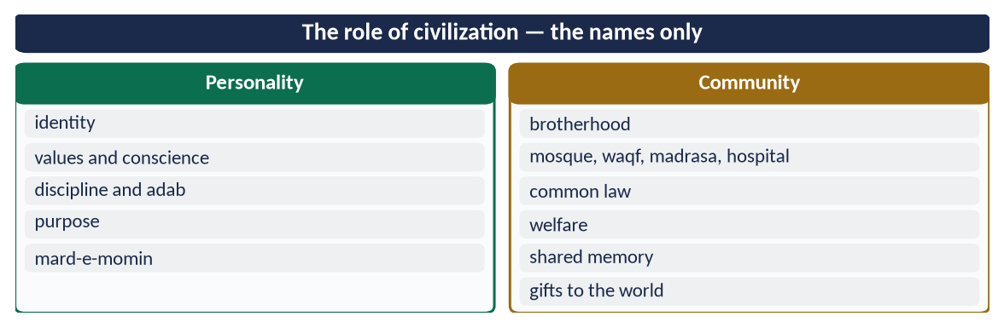
Figure 5 · At a glance — the role of civilization — the names only. The detail is in the sections above.

Chapter 3 · Tawhid: The Foundation of Islamic Civilization

3.1 Tawhid — the meaning
Tawhid (تَوْحِيد) is to believe that Allah is One — in His Lordship, His right to worship, and His names and attributes (Topic 1).
✦ QURAN
﴿قُلۡ هُوَ ٱللَّهُ أَحَدٌ ۝ ٱللَّهُ ٱلصَّمَدُ ۝ لَمۡ يَلِدۡ وَلَمۡ يُولَدۡ ۝ وَلَمۡ يَكُن لَّهُۥ كُفُوًا أَحَدُۢ﴾
“Say, "He is Allah, [who is] One. Allah, the Eternal Refuge. He neither begets nor is born. Nor is there to Him any equivalent.” (Al-Ikhlas, Quran)
➜ 'Say: He is Allah, the One … there is none equal to Him.'

3.2 How Tawhid builds a civilization

(1) One God → one humanity
If all people are servants of one Lord, no race, class or nation is born superior.
✦ QURAN
﴿يَـٰٓأَيُّهَا ٱلنَّاسُ إِنَّا خَلَقۡنَٰكُم مِّن ذَكَرٖ وَأُنثَىٰ وَجَعَلۡنَٰكُمۡ شُعُوبٗا وَقَبَآئِلَ لِتَعَارَفُوٓاْۚ إِنَّ أَكۡرَمَكُمۡ عِندَ ٱللَّهِ أَتۡقَىٰكُمۡۚ إِنَّ ٱللَّهَ عَلِيمٌ خَبِيرٞ﴾
“O mankind, indeed We have created you from male and female and made you peoples and tribes that you may know one another. Indeed, the most noble of you in the sight of Allah is the most righteous of you. Indeed, Allah is Knowing and Acquainted.” (Al-Hujurat, Quran)
➜ Honour is by taqwa, not birth.

✦ SCHOLARLY VIEW
Allama Muhammad Iqbal · The Reconstruction of Religious Thought in Islam, Lecture VI
Iqbal wrote that the essence of Tawhid, as a working idea, is equality, solidarity and freedom.
➜ Tawhid is a social principle, not only a creed.

(2) Freedom from all false masters
Tawhid frees man from kings, priests, idols, superstition and his own desires.
✦ QURAN
﴿قُلۡ يَـٰٓأَهۡلَ ٱلۡكِتَٰبِ تَعَالَوۡاْ إِلَىٰ كَلِمَةٖ سَوَآءِۭ بَيۡنَنَا وَبَيۡنَكُمۡ أَلَّا نَعۡبُدَ إِلَّا ٱللَّهَ وَلَا نُشۡرِكَ بِهِۦ شَيۡـٔٗا وَلَا يَتَّخِذَ بَعۡضُنَا بَعۡضًا أَرۡبَابٗا مِّن دُونِ ٱللَّهِۚ …﴾
“Say: O People of the Scripture, come to a word common between us and you: that we worship none but Allah, associate nothing with Him, and that none of us take others as lords besides Allah.” (Aal-e-Imran, Quran)
➜ '… that we worship none but Allah … and do not take one another as lords besides Allah.'

(3) Unity of knowledge and life
No split between 'sacred' and 'secular': prayer, trade, science and government all serve the one God. This is why mosques had schools beside them and scholars were also physicians and astronomers.

(4) Freedom for science
When nature is not divine, it can be studied. The Quran invites observation:
✦ QURAN
﴿إِنَّ فِي خَلۡقِ ٱلسَّمَٰوَٰتِ وَٱلۡأَرۡضِ وَٱخۡتِلَٰفِ ٱلَّيۡلِ وَٱلنَّهَارِ لَأٓيَٰتٖ لِّأُوْلِي ٱلۡأَلۡبَٰبِ﴾
“Indeed, in the creation of the heavens and the earth and the alternation of the night and the day are signs for those of understanding.” (Aal-e-Imran, Quran)
➜ In the creation of the heavens and the earth and the alternation of night and day are signs for people of understanding.

(5) Accountability and morality
Belief in one All-Seeing God and one Day of Judgement creates conscience — the inner police of the civilization.

(6) Unity of the Ummah
One God, one Book, one Prophet, one qiblah — a civilization that stretched from Spain to Indonesia without a single race or language.
✦ SCHOLARLY VIEW
Dr Isma'il Raji al-Faruqi · Al-Tawhid: Its Implications for Thought and Life (1982)
Al-Faruqi argued that Tawhid is the first principle of Islamic civilization — of its ethics, its social order, its science and its art (which avoids images of God and uses the infinite pattern).
➜ Tawhid shapes even the art.

(7) Tawhid in art and architecture
Because Allah cannot be pictured, Islamic art developed calligraphy, geometry and the arabesque — patterns without end, pointing to the Infinite: the Dome of the Rock, the Alhambra, the Badshahi Mosque, the Faisal Mosque.
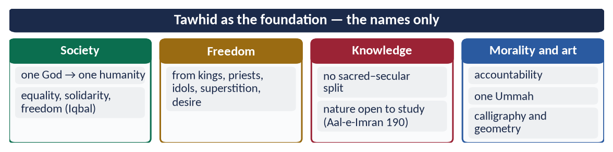
Figure 6 · At a glance — tawhid as the foundation — the names only. The detail is in the sections above.

Chapter 4 · Tazkiyah and Ihsan: Self-Purification
The examiner's favourite: 2017 (concept and impact on society), 2018 (self-purification and Ihsan; individual and collective impacts), 2024 (an essential element for the evolution of society).

4.1 The meaning of Tazkiyah

(1) Literal meaning
Tazkiyah (تَزْكِيَة) has two meanings: purification — removing dirt — and growth — making something flourish. The same root gives Zakat.

(2) Technical meaning
Tazkiyat al-nafs is cleansing the self of evil traits (pride, envy, greed, hypocrisy) and developing good traits (sincerity, patience, gratitude, humility), so that a person obeys Allah willingly and lives with a sound heart.

4.2 Tazkiyah in the Quran

(1) Success depends on it
✦ QURAN
﴿وَنَفۡسٖ وَمَا سَوَّىٰهَا ۝ فَأَلۡهَمَهَا فُجُورَهَا وَتَقۡوَىٰهَا ۝ قَدۡ أَفۡلَحَ مَن زَكَّىٰهَا ۝ وَقَدۡ خَابَ مَن دَسَّىٰهَا﴾
“And [by] the soul and He who proportioned it. And inspired it [with discernment of] its wickedness and its righteousness. He has succeeded who purifies it. And he has failed who instills it [with corruption].” (Ash-Shams, Quran)
➜ By the soul and Him who proportioned it, and inspired it with its wickedness and its righteousness: he has succeeded who purifies it, and he has failed who corrupts it.

✦ QURAN
﴿قَدۡ أَفۡلَحَ مَن تَزَكَّىٰ﴾
“He has certainly succeeded who purifies himself.” (Al-A'la, Quran)
➜ 'He has certainly succeeded who purifies himself.'

(2) A purpose of the Prophethood
✦ QURAN
﴿هُوَ ٱلَّذِي بَعَثَ فِي ٱلۡأُمِّيِّـۧنَ رَسُولٗا مِّنۡهُمۡ يَتۡلُواْ عَلَيۡهِمۡ ءَايَٰتِهِۦ وَيُزَكِّيهِمۡ وَيُعَلِّمُهُمُ ٱلۡكِتَٰبَ وَٱلۡحِكۡمَةَ وَإِن كَانُواْ مِن قَبۡلُ لَفِي ضَلَٰلٖ مُّبِينٖ﴾
“It is He who has sent among the unlettered a Messenger from themselves reciting to them His verses and purifying them and teaching them the Book and wisdom - although they were before in clear error.” (Al-Jumu'ah, Quran)
➜ The Messenger recites the verses, purifies them (yuzakkihim) and teaches the Book and wisdom.

(3) The sound heart on the Last Day
✦ QURAN
﴿يَوۡمَ لَا يَنفَعُ مَالٞ وَلَا بَنُونَ ۝ إِلَّا مَنۡ أَتَى ٱللَّهَ بِقَلۡبٖ سَلِيمٖ﴾
“The Day when there will not benefit [anyone] wealth or children. But only one who comes to Allah with a sound heart.” (Ash-Shu'ara, Quran)
➜ The day when neither wealth nor sons will benefit — except one who comes to Allah with a sound heart.

(4) Restraining desire
✦ QURAN
﴿وَأَمَّا مَنۡ خَافَ مَقَامَ رَبِّهِۦ وَنَهَى ٱلنَّفۡسَ عَنِ ٱلۡهَوَىٰ ۝ فَإِنَّ ٱلۡجَنَّةَ هِيَ ٱلۡمَأۡوَىٰ﴾
“But as for he who feared the position of his Lord and prevented the soul from [unlawful] inclination. Then indeed, Paradise will be [his] refuge.” (An-Nazi'at, Quran)
➜ Whoever feared standing before his Lord and restrained the soul from desire — Paradise will be his refuge.

(5) The three stages of the self
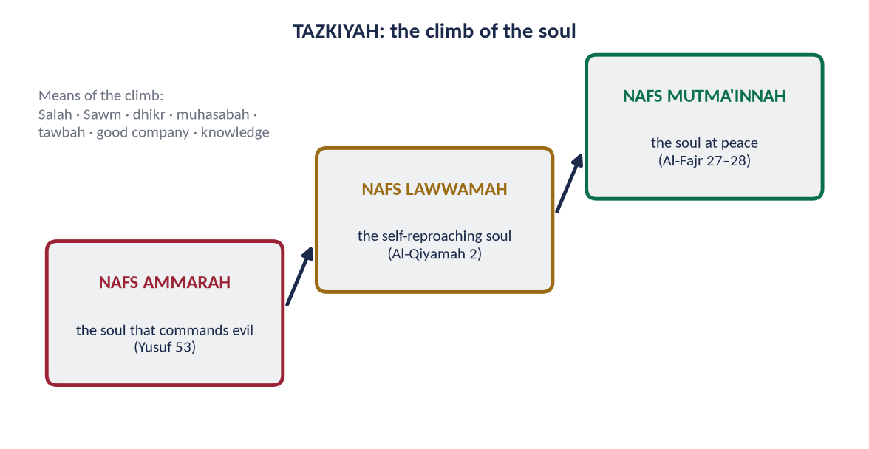
Figure 7 · The three stages of the soul in the Quran — tazkiyah is the climb.
Stage | Arabic | Meaning and verse
Nafs ammarah | النَّفْسُ الْأَمَّارَة | The soul that commands evil (Yusuf 53)
Nafs lawwamah | النَّفْسُ اللَّوَّامَة | The self-reproaching soul — the conscience (Al-Qiyamah 2)
Nafs mutma'innah | النَّفْسُ الْمُطْمَئِنَّة | The soul at peace, returning to its Lord pleased (Al-Fajr 27–28)

4.3 Tazkiyah in the Sunnah
✦ HADITH
أَلَا وَإِنَّ فِي الْجَسَدِ مُضْغَةً إِذَا صَلَحَتْ صَلَحَ الْجَسَدُ كُلُّهُ، وَإِذَا فَسَدَتْ فَسَدَ الْجَسَدُ كُلُّهُ، أَلَا وَهِيَ الْقَلْبُ
“Truly, in the body there is a piece of flesh; if it is sound, the whole body is sound, and if it is corrupt, the whole body is corrupt. Truly, it is the heart.” (Al-Bukhari and Muslim)
➜ Reform begins in the heart.

✦ HADITH
إِنَّ اللَّهَ لَا يَنْظُرُ إِلَى صُوَرِكُمْ وَأَمْوَالِكُمْ، وَلَكِنْ يَنْظُرُ إِلَى قُلُوبِكُمْ وَأَعْمَالِكُمْ
“Allah does not look at your appearance or your wealth, but at your hearts and your deeds.” (Muslim)

✦ HADITH
الْمُجَاهِدُ مَنْ جَاهَدَ نَفْسَهُ
“The true striver (mujahid) is the one who strives against his own self.” (Al-Tirmidhi)
➜ Jihad al-nafs — the inner struggle.

4.4 Ihsan — the highest level of faith
✦ HADITH
أَنْ تَعْبُدَ اللَّهَ كَأَنَّكَ تَرَاهُ، فَإِنْ لَمْ تَكُنْ تَرَاهُ فَإِنَّهُ يَرَاكَ
“That you worship Allah as though you see Him; and if you do not see Him, He certainly sees you.” (Muslim)
➜ The Prophet's ﷺ answer to Jibril: Ihsan (إِحْسَان) — worship and life lived in the awareness of Allah.

- Islam — the outward acts; Iman — the inner beliefs; Ihsan — the quality of both (the hadith of Jibril).
- Ihsan also means excellence towards people: 'Allah has prescribed ihsan in everything' (Muslim).
✦ QURAN
﴿إِنَّ ٱللَّهَ يَأۡمُرُ بِٱلۡعَدۡلِ وَٱلۡإِحۡسَٰنِ وَإِيتَآيِٕ ذِي ٱلۡقُرۡبَىٰ وَيَنۡهَىٰ عَنِ ٱلۡفَحۡشَآءِ وَٱلۡمُنكَرِ وَٱلۡبَغۡيِۚ يَعِظُكُمۡ لَعَلَّكُمۡ تَذَكَّرُونَ﴾
“Indeed, Allah orders justice and good conduct and giving to relatives and forbids immorality and bad conduct and oppression. He admonishes you that perhaps you will be reminded.” (An-Nahl, Quran)
➜ Allah commands justice ('adl) and excellence (ihsan) — Ihsan goes beyond justice: giving more than is due.

✦ QURAN
﴿وَأَنفِقُواْ فِي سَبِيلِ ٱللَّهِ وَلَا تُلۡقُواْ بِأَيۡدِيكُمۡ إِلَى ٱلتَّهۡلُكَةِ وَأَحۡسِنُوٓاْۚ إِنَّ ٱللَّهَ يُحِبُّ ٱلۡمُحۡسِنِينَ﴾
“And spend in the way of Allah and do not throw [yourselves] with your [own] hands into destruction [by refraining]. And do good; indeed, Allah loves the doers of good.” (Al-Baqarah, Quran)
➜ 'Do good; Allah loves the doers of good (muhsinin).'

4.5 The means of Tazkiyah
Means | How it purifies
Salah | Restrains from indecency and evil (Al-Ankabut 45)
Sawm | Builds taqwa; controls desire (Al-Baqarah 183)
Zakat and charity | Purifies from greed (At-Tawbah 103)
Dhikr (remembrance) | 'In the remembrance of Allah hearts find rest' (Ar-Ra'd 28)
Muhasabah (self-accounting) | 'Take account of yourselves before you are taken to account' — Umar (RA), reported by Al-Tirmidhi
Tawbah (repentance) | Wipes away sin; turns the soul back
Good company | 'Be with the truthful' (At-Tawbah 119)
Knowledge | Only those with knowledge truly fear Allah (Fatir 28)
Reflection on death and the Hereafter | Cuts attachment to the world

4.6 The diseases and the virtues of the heart

(1) The diseases (muhlikat — the destroyers)
- Pride (kibr):
✦ HADITH
لَا يَدْخُلُ الْجَنَّةَ مَنْ كَانَ فِي قَلْبِهِ مِثْقَالُ ذَرَّةٍ مِنْ كِبْرٍ
“No one will enter Paradise who has in his heart an atom's weight of pride.” (Muslim)

- Envy (hasad): 'Beware of envy, for envy consumes good deeds as fire consumes wood' (Abu Dawud).
- Showing off (riya'): called 'the minor shirk' (Ahmad).
- Greed, anger, backbiting, love of the world.

(2) The virtues (munjiyat — the saviours)
Sincerity (ikhlas), patience (sabr), gratitude (shukr), trust (tawakkul), humility (tawadu'), modesty (haya'), contentment (qana'ah), love of Allah.
✦ HADITH
الْحَيَاءُ شُعْبَةٌ مِنَ الْإِيمَانِ
“Modesty is a branch of faith.” (Al-Bukhari and Muslim)

✦ SCHOLARLY VIEW
Imam al-Ghazali · Ihya' 'Ulum al-Din
Al-Ghazali divided his great work into four quarters — acts of worship, social customs, the destroyers (muhlikat) and the saviours (munjiyat) — showing that the rituals and daily dealings are means, and the purification of the heart is the goal.
➜ The classic manual of Tazkiyah.

4.7 The individual impacts of Tazkiyah
- (a) Inner peace — 'in the remembrance of Allah hearts find rest'.
- (b) Sincerity and integrity — the same person in private and public.
- (c) Self-control — over anger, desire and greed.
- (d) Moral excellence — honesty, humility, patience.
- (e) Mental health — freedom from envy, anxiety and despair.
- (f) Success in both worlds — 'he has succeeded who purifies it'.

4.8 The collective impacts — self-purification and the evolution of society (2024)
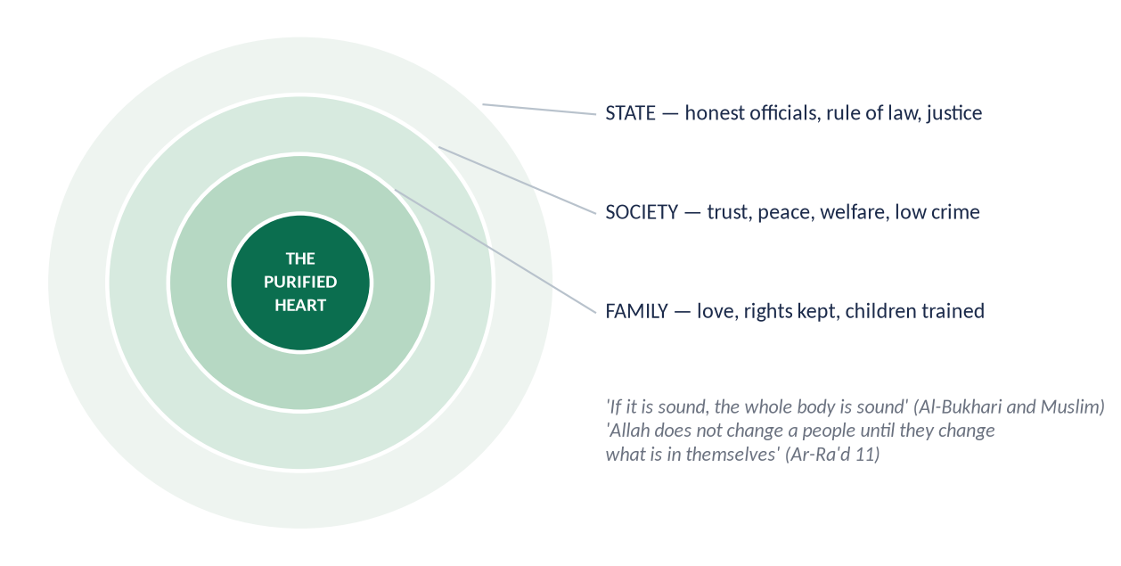
Figure 8 · From the purified heart to the family, society and state.

(1) The Quranic law of social change
✦ QURAN
﴿… إِنَّ ٱللَّهَ لَا يُغَيِّرُ مَا بِقَوۡمٍ حَتَّىٰ يُغَيِّرُواْ مَا بِأَنفُسِهِمۡۗ …﴾
“Indeed, Allah will not change the condition of a people until they change what is in themselves.” (Ar-Ra'd, Quran)
➜ Allah does not change the condition of a people until they change what is in themselves — social change begins inside.

(2) The impacts on society
Area | Collective impact
Family | Rights kept, love and patience, children trained by example
Economy | Honest trade, no fraud, hoarding or riba; generosity
Governance | Officials who fear Allah — less corruption; rulers as servants
Justice | Truthful witnesses, fair judges
Social harmony | No envy, backbiting or arrogance; trust and brotherhood
Crime | Inner restraint reduces crime more than police
Civilization | Ibn Khaldun: luxury and moral decay destroy civilizations; purity preserves them

(3) The historical proof
The Companions, purified by the Prophet ﷺ, built the most just society in history in one generation. Umar (RA) carried flour on his back to a hungry widow at night; Abu Ubaydah (RA), governor of Syria, lived in a house with a sword, a shield and a saddle. The Quran describes that generation:
✦ QURAN
﴿مُّحَمَّدٞ رَّسُولُ ٱللَّهِۚ وَٱلَّذِينَ مَعَهُۥٓ أَشِدَّآءُ عَلَى ٱلۡكُفَّارِ رُحَمَآءُ بَيۡنَهُمۡۖ تَرَىٰهُمۡ رُكَّعٗا سُجَّدٗا يَبۡتَغُونَ فَضۡلٗا مِّنَ ٱللَّهِ وَرِضۡوَٰنٗاۖ سِيمَاهُمۡ فِي وُجُوهِهِم مِّنۡ أَثَرِ ٱلسُّجُودِۚ …﴾
“Muhammad is the Messenger of Allah; those with him are firm against the disbelievers, merciful among themselves; you see them bowing and prostrating, seeking bounty from Allah and His pleasure; their mark is on their faces from the trace of prostration.” (Al-Fath, Quran)
➜ Firm against the disbelievers, merciful among themselves … their mark is on their faces from prostration.

(4) The evolution of society
Every reform movement in Muslim history — Umar ibn Abd al-Aziz, Imam al-Ghazali, Shaykh Ahmad Sirhindi, Shah Waliullah — began with the reform of the self. A society evolves when its individuals evolve.
PAKISTAN · THE MISSING ELEMENT
Pakistan has mosques, madrasas and laws, yet corruption, adulteration and dishonesty remain widespread (Transparency International CPI 2024: 135th of 180). The gap is tazkiyah: rituals without purification of the heart. The Quran's order is 'recite, purify, teach' — purification before information.

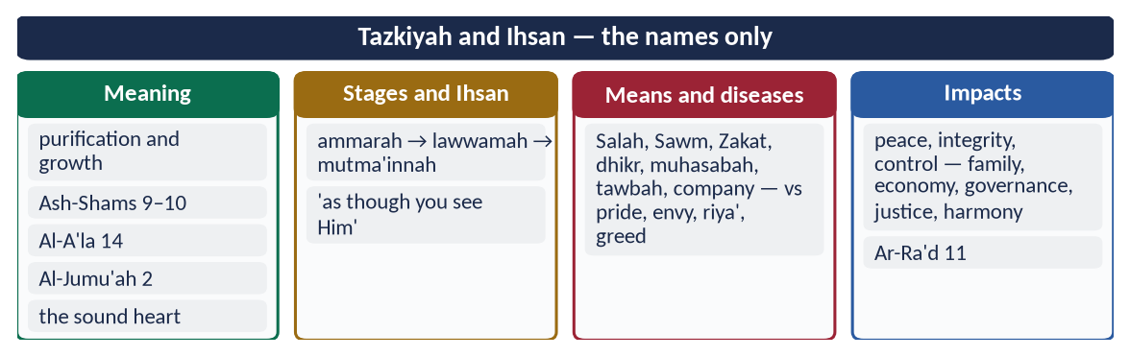
Figure 9 · At a glance — tazkiyah and Ihsan — the names only. The detail is in the sections above.

Chapter 5 · Sufism: Its Role and Its Reform
Asked in 2021: 'Explore the importance of Sufism to spread out Islam. Is the amelioration of current deviation possible through Sufism?'

5.1 The meaning of Sufism

(1) The word
Tasawwuf (تَصَوُّف) is linked by scholars to suf (wool — the simple dress of the early ascetics), safa' (purity of heart) or the Ahl al-Suffah (the poor students of the Prophet's ﷺ mosque).

(2) The concept
Sufism is the discipline of the heart — the practical path of tazkiyah and ihsan: sincerity, remembrance, love of Allah and service of His creation, within the Shari'ah.
✦ SCHOLARLY VIEW
Imam al-Qushayri · Al-Risalah al-Qushayriyyah
Al-Qushayri, writing when he saw Sufism mixed with claims without practice, defined it as holding to the Quran and Sunnah, purifying the heart and adorning it with good character — and insisted that any 'spiritual state' contrary to the Shari'ah is false.
➜ Sufism is Tazkiyah within the Shari'ah.

5.2 The early masters
Hasan al-Basri (d. 110 AH) — asceticism and fear of Allah; Rabi'ah al-Adawiyyah (d. 185 AH) — worship for the love of Allah, not fear of Hell or hope of Paradise; Junayd al-Baghdadi (d. 298 AH) — 'sober' Sufism bound by the Shari'ah; Imam al-Ghazali (d. 505 AH) — reconciled Sufism with law and theology in the Ihya'; Shaykh Abd al-Qadir Jilani (d. 561 AH) — founder of the Qadiri order, preacher of repentance in Baghdad.

5.3 The Sufis and the spread of Islam in the subcontinent
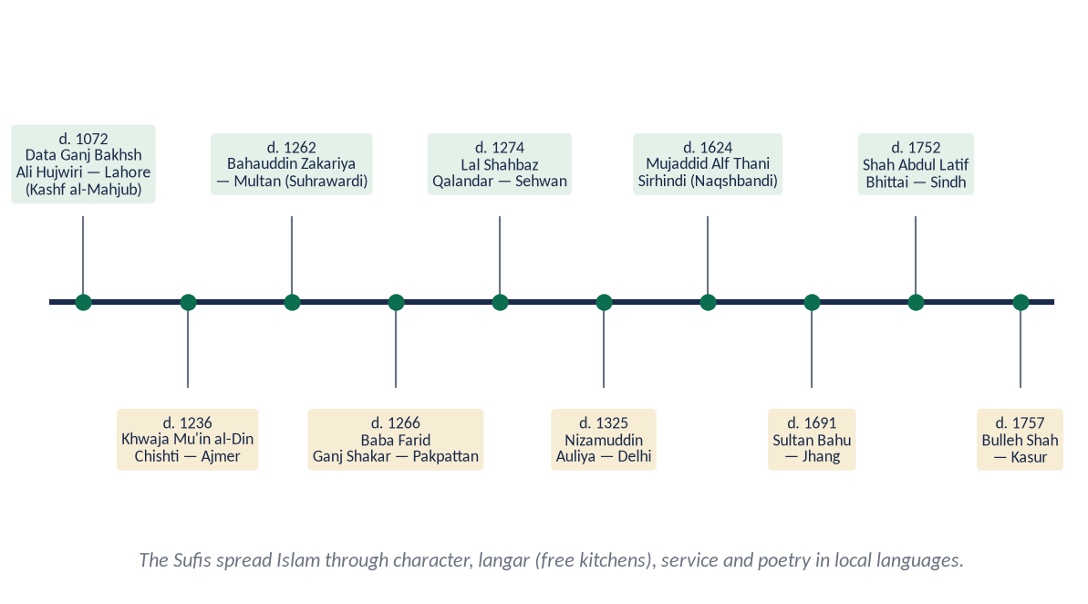
Figure 10 · The great Sufis of the subcontinent.

(1) The main orders (silsilahs)
Order | Founder / great figure in the subcontinent | Centre
Chishti | Khwaja Mu'in al-Din Chishti (d. 1236); Baba Farid; Nizamuddin Auliya | Ajmer, Pakpattan, Delhi
Suhrawardi | Shaykh Bahauddin Zakariya (d. 1262) | Multan, Uch
Qadiri | Followers of Shaykh Abd al-Qadir Jilani; Mian Mir (Lahore) | Lahore, Sindh
Naqshbandi | Khwaja Baqi Billah; Shaykh Ahmad Sirhindi, Mujaddid Alf Thani (d. 1624) | Delhi, Sirhind

Data Ganj Bakhsh Ali Hujwiri (d. c. 1072), buried in Lahore, wrote Kashf al-Mahjub — the first treatise on Sufism in Persian.

(2) How the Sufis spread Islam
- (a) Character before words: honesty, humility and care for the poor won hearts in a caste-bound society.
✦ QURAN
﴿ٱدۡعُ إِلَىٰ سَبِيلِ رَبِّكَ بِٱلۡحِكۡمَةِ وَٱلۡمَوۡعِظَةِ ٱلۡحَسَنَةِۖ وَجَٰدِلۡهُم بِٱلَّتِي هِيَ أَحۡسَنُۚ …﴾
“Invite to the way of your Lord with wisdom and good instruction, and argue with them in the way that is best.” (An-Nahl, Quran)
➜ Invite with wisdom and good instruction — the Sufi method.

- (b) Equality in the langar: at the free kitchens, high caste and low caste, rich and poor ate together — a living denial of caste.
- (c) Service of creation: feeding the hungry, sheltering travellers, caring for the sick.
- (d) Local languages and poetry: Punjabi (Baba Farid, Sultan Bahu, Bulleh Shah), Sindhi (Shah Abdul Latif Bhittai, Shah jo Risalo), Pashto (Rahman Baba), Saraiki — Islam entered the heart in the people's own tongue.
- (e) Khanqah as a school: the khanqah taught the Quran, adab and discipline.
- (f) Peaceful example: no compulsion — people embraced Islam freely.
✦ SCHOLARLY VIEW
Sir Thomas W. Arnold · The Preaching of Islam (1896)
Arnold, a British orientalist and teacher of Iqbal, showed that Islam spread in India and elsewhere mainly through the peaceful preaching of traders and Sufis, not through the sword.
➜ A Western historian's evidence.

(3) The Sufis as reformers
Shaykh Ahmad Sirhindi (Mujaddid Alf Thani) opposed Emperor Akbar's religious syncretism (Din-i-Ilahi), insisting that the Sufi path must follow the Shari'ah; Shah Waliullah combined Sufism with Hadith scholarship and social reform.

5.4 The present deviations
Deviation | Why the great Sufis themselves rejected it
Prostration and petitions to graves | Worship is for Allah alone (Al-Fatihah 5); the Sufis taught Tawhid
Neglect of Salah and Shari'ah | Hujwiri and Sirhindi: no tariqah without Shari'ah
Hereditary gaddi and fake pirs | Spiritual rank is by piety, not birth; exploitation of the poor
Commercialism at shrines | Religion sold for money and votes
Drugs, dance and music at 'urs | Against the Shari'ah and the Sufis' own discipline
Superstition and amulets for profit | Contrary to tawakkul

TRAP · STAY ABOVE THE SECTARIAN DEBATE
Do not attack any school or name any living group. Say: the deviations are rejected by the great Sufis themselves — Hujwiri, Sirhindi, Shah Waliullah — and by every school of Islam. Criticise practices, not people.

5.5 Is the reform of today's deviations possible through Sufism?

Yes — if Sufism returns to its own foundations
- (a) Sufism is Tazkiyah: society's deviations — corruption, greed, violence, hatred — are diseases of the heart, and Sufism is the science of the heart.
- (b) Shari'ah first: reformed Sufism, in the tradition of Sirhindi and Shah Waliullah, joins the inner path to the law.
- (c) Tolerance against extremism: the Sufi message of love and service is an antidote to sectarian hatred and militancy.
- (d) Service and equality: the langar model answers class pride.
- (e) Reform of the shrines: the state took over major shrines under the Auqaf law of 1960–61; shrines can become centres of education, welfare and Quran teaching, as Data Darbar's services show.

The conditions
Sound knowledge; the Shari'ah as the criterion; no commercial or political exploitation; sincere guides, not hereditary claimants.
✦ QURAN
﴿يَـٰٓأَيُّهَا ٱلَّذِينَ ءَامَنُواْ ٱتَّقُواْ ٱللَّهَ وَكُونُواْ مَعَ ٱلصَّـٰدِقِينَ﴾
“O you who have believed, fear Allah and be with those who are true.” (At-Tawbah, Quran)
➜ 'Fear Allah and be with the truthful' — the good company that Sufism at its best provides.

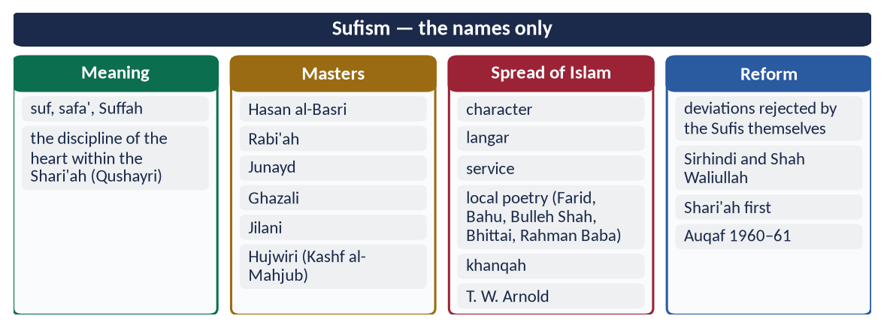
Figure 11 · At a glance — sufism — the names only. The detail is in the sections above.

Chapter 6 · The Dignity of Man
The full treatment is in Topic 4, Chapter 4; here, dignity is shown as a characteristic of the civilization.
✦ QURAN
﴿وَلَقَدۡ كَرَّمۡنَا بَنِيٓ ءَادَمَ وَحَمَلۡنَٰهُمۡ فِي ٱلۡبَرِّ وَٱلۡبَحۡرِ وَرَزَقۡنَٰهُم مِّنَ ٱلطَّيِّبَٰتِ وَفَضَّلۡنَٰهُمۡ عَلَىٰ كَثِيرٖ مِّمَّنۡ خَلَقۡنَا تَفۡضِيلٗا﴾
“And We have certainly honored the children of Adam and carried them on the land and sea and provided for them of the good things and preferred them over much of what We have created, with [definite] preference.” (Al-Isra, Quran)
➜ 'We have honoured the children of Adam' — dignity belongs to every human being.

6.1 Dignity as a civilizational principle
- (a) Given by Allah: created in the best form (At-Tin 4), with His spirit breathed into him (Al-Hijr 29), as His vicegerent (Al-Baqarah 30).
- (b) Protected by law: life, property and honour sacred (Farewell Sermon); no mockery, spying or backbiting (Al-Hujurat 11–12).
- (c) In every condition: the poor, the servant, the criminal, the enemy and the dead — 'breaking a dead man's bone is like breaking it alive' (Abu Dawud).

6.2 How dignity shaped the civilization
- Abolition of degrading practices — female infanticide, mutilation, and the gradual freeing of slaves through expiations and Zakat ('fi al-riqab').
- Dignity of labour — the Prophet ﷺ mended his clothes; 'no one eats better food than what he earns with his own hands' (Al-Bukhari).
- Dignity of knowledge — scholars honoured above rulers; slaves and freedmen became leading scholars (Ata ibn Abi Rabah, Nafi').
- Dignity of the non-Muslim — the mu'ahad protected (Al-Bukhari; Abu Dawud).
✦ HADITH
إِخْوَانُكُمْ خَوَلُكُمْ ... فَلْيُطْعِمْهُ مِمَّا يَأْكُلُ، وَلْيُلْبِسْهُ مِمَّا يَلْبَسُ
“Your servants are your brothers … feed them from what you eat and clothe them from what you wear.” (Al-Bukhari)
➜ Dignity inside the home.

Chapter 7 · Equality and the Classist Lifestyle
Asked in 2025: 'Determine the status of the classist lifestyle in the light of the teachings of Islam and examine its effects on human society.'

7.1 What is a 'classist lifestyle'?
A classist lifestyle is a way of living that divides people by wealth, status or birth and displays that division — expensive houses, cars, clothes, weddings and schools used to show superiority, and the poor treated as lower human beings. Historically it appears as aristocracy, feudalism and caste; today as consumerism and elite privilege.

7.2 Equality in Islam
✦ QURAN
﴿يَـٰٓأَيُّهَا ٱلنَّاسُ إِنَّا خَلَقۡنَٰكُم مِّن ذَكَرٖ وَأُنثَىٰ وَجَعَلۡنَٰكُمۡ شُعُوبٗا وَقَبَآئِلَ لِتَعَارَفُوٓاْۚ إِنَّ أَكۡرَمَكُمۡ عِندَ ٱللَّهِ أَتۡقَىٰكُمۡۚ إِنَّ ٱللَّهَ عَلِيمٌ خَبِيرٞ﴾
“O mankind, indeed We have created you from male and female and made you peoples and tribes that you may know one another. Indeed, the most noble of you in the sight of Allah is the most righteous of you. Indeed, Allah is Knowing and Acquainted.” (Al-Hujurat, Quran)
➜ Created from one male and one female, made into nations and tribes to know one another; the most honoured is the most righteous.

✦ FROM THE SIRAH
لَا فَضْلَ لِعَرَبِيٍّ عَلَى عَجَمِيٍّ، وَلَا لِعَجَمِيٍّ عَلَى عَرَبِيٍّ، وَلَا لِأَحْمَرَ عَلَى أَسْوَدَ، وَلَا أَسْوَدَ عَلَى أَحْمَرَ، إِلَّا بِالتَّقْوَى
“No Arab has superiority over a non-Arab … nor white over black … except by taqwa.” (Musnad Ahmad (the Farewell Sermon))

- In worship: the rich and the poor stand in one row; in Hajj all wear two white sheets.
- Before law: 'If Fatimah daughter of Muhammad stole, I would cut her hand' (Al-Bukhari and Muslim).
- In opportunity: Bilal, Salman and Usamah rose by merit.

7.3 Difference in wealth is a test, not a rank
✦ QURAN
﴿… وَرَفَعۡنَا بَعۡضَهُمۡ فَوۡقَ بَعۡضٖ دَرَجَٰتٖ لِّيَتَّخِذَ بَعۡضُهُم بَعۡضٗا سُخۡرِيّٗاۗ …﴾
“And We have raised some of them above others in degrees, so that they may take one another into service.” (Az-Zukhruf, Quran)
➜ Allah raised some above others in degrees so that they may take one another into service — difference in means is for mutual need, not for pride.

✦ QURAN
﴿وَهُوَ ٱلَّذِي جَعَلَكُمۡ خَلَـٰٓئِفَ ٱلۡأَرۡضِ وَرَفَعَ بَعۡضَكُمۡ فَوۡقَ بَعۡضٖ دَرَجَٰتٖ لِّيَبۡلُوَكُمۡ فِي مَآ ءَاتَىٰكُمۡۗ إِنَّ رَبَّكَ سَرِيعُ ٱلۡعِقَابِ وَإِنَّهُۥ لَغَفُورٞ رَّحِيمُۢ﴾
“And it is He who has made you successors upon the earth and has raised some of you above others in degrees [of rank] that He may try you through what He has given you. Indeed, your Lord is swift in penalty; but indeed, He is Forgiving and Merciful.” (Al-An'am, Quran)
➜ He raised some of you above others in degrees to test you in what He has given you.

Islam accepts differences of income; it rejects pride, display and exploitation built on them.

7.4 The status of the classist lifestyle in Islam

(1) Pride and arrogance — condemned
✦ QURAN
﴿وَلَا تُصَعِّرۡ خَدَّكَ لِلنَّاسِ وَلَا تَمۡشِ فِي ٱلۡأَرۡضِ مَرَحًاۖ إِنَّ ٱللَّهَ لَا يُحِبُّ كُلَّ مُخۡتَالٖ فَخُورٖ ۝ وَٱقۡصِدۡ فِي مَشۡيِكَ وَٱغۡضُضۡ مِن صَوۡتِكَۚ …﴾
“Do not turn your cheek in contempt towards people, nor walk proudly on the earth — Allah does not love the arrogant boaster. Be moderate in your walk and lower your voice.” (Luqman, Quran)
➜ Do not turn your cheek in contempt towards people or walk proudly; be moderate in your walk and lower your voice.

✦ HADITH
لَا يَدْخُلُ الْجَنَّةَ مَنْ كَانَ فِي قَلْبِهِ مِثْقَالُ ذَرَّةٍ مِنْ كِبْرٍ
“No one will enter Paradise who has an atom's weight of pride in his heart.” (Muslim)
➜ Asked what pride is, he said: 'rejecting the truth and looking down on people.'

(2) Competition in wealth and display — condemned
✦ QURAN
﴿أَلۡهَىٰكُمُ ٱلتَّكَاثُرُ ۝ حَتَّىٰ زُرۡتُمُ ٱلۡمَقَابِرَ﴾
“Competition in [worldly] increase diverts you. Until you visit the graveyards.” (At-Takathur, Quran)
➜ 'Competition in increase distracts you until you visit the graves.'

✦ QURAN
﴿ٱعۡلَمُوٓاْ أَنَّمَا ٱلۡحَيَوٰةُ ٱلدُّنۡيَا لَعِبٞ وَلَهۡوٞ وَزِينَةٞ وَتَفَاخُرُۢ بَيۡنَكُمۡ وَتَكَاثُرٞ فِي ٱلۡأَمۡوَٰلِ وَٱلۡأَوۡلَٰدِۖ …﴾
“Know that the life of this world is only play and amusement, adornment, boasting to one another, and competition in wealth and children.” (Al-Hadid, Quran)
➜ The life of this world is play, adornment, boasting to one another and competition in wealth and children.

✦ QURAN
﴿وَيۡلٞ لِّكُلِّ هُمَزَةٖ لُّمَزَةٍ ۝ ٱلَّذِي جَمَعَ مَالٗا وَعَدَّدَهُۥ ۝ يَحۡسَبُ أَنَّ مَالَهُۥٓ أَخۡلَدَهُۥ﴾
“Woe to every scorner and mocker. Who collects wealth and [continuously] counts it. He thinks that his wealth will make him immortal.” (Al-Humazah, Quran)
➜ Woe to every slanderer and backbiter who gathers wealth and counts it, thinking his wealth will make him immortal.

(3) Extravagance — condemned
✦ QURAN
﴿وَءَاتِ ذَا ٱلۡقُرۡبَىٰ حَقَّهُۥ وَٱلۡمِسۡكِينَ وَٱبۡنَ ٱلسَّبِيلِ وَلَا تُبَذِّرۡ تَبۡذِيرًا ۝ إِنَّ ٱلۡمُبَذِّرِينَ كَانُوٓاْ إِخۡوَٰنَ ٱلشَّيَٰطِينِۖ وَكَانَ ٱلشَّيۡطَٰنُ لِرَبِّهِۦ كَفُورٗا﴾
“And give the relative his right, and [also] the poor and the traveler, and do not spend wastefully. Indeed, the wasteful are brothers of the devils, and ever has Satan been to his Lord ungrateful.” (Al-Isra, Quran)
➜ Do not squander wastefully; the squanderers are brothers of the devils.

✦ QURAN
﴿وَٱلَّذِينَ إِذَآ أَنفَقُواْ لَمۡ يُسۡرِفُواْ وَلَمۡ يَقۡتُرُواْ وَكَانَ بَيۡنَ ذَٰلِكَ قَوَامٗا﴾
“And [they are] those who, when they spend, do so not excessively or sparingly but are ever, between that, [justly] moderate.” (Al-Furqan, Quran)
➜ The servants of the Most Merciful, when they spend, are neither extravagant nor miserly but moderate.

✦ HADITH
كُلُوا وَاشْرَبُوا وَالْبَسُوا وَتَصَدَّقُوا فِي غَيْرِ إِسْرَافٍ وَلَا مَخِيلَةٍ
“Eat, drink, dress and give charity — without extravagance or arrogance.” (Musnad Ahmad and Al-Nasa'i)
➜ The Islamic consumer rule.

✦ HADITH
مَنْ لَبِسَ ثَوْبَ شُهْرَةٍ فِي الدُّنْيَا، أَلْبَسَهُ اللَّهُ ثَوْبَ مَذَلَّةٍ يَوْمَ الْقِيَامَةِ
“Whoever wears a garment of fame in this world, Allah will clothe him in a garment of humiliation on the Day of Resurrection.” (Abu Dawud)
➜ Status display is condemned.

(4) Contempt for the poor — condemned
✦ QURAN
﴿وَٱصۡبِرۡ نَفۡسَكَ مَعَ ٱلَّذِينَ يَدۡعُونَ رَبَّهُم بِٱلۡغَدَوٰةِ وَٱلۡعَشِيِّ يُرِيدُونَ وَجۡهَهُۥۖ وَلَا تَعۡدُ عَيۡنَاكَ عَنۡهُمۡ تُرِيدُ زِينَةَ ٱلۡحَيَوٰةِ ٱلدُّنۡيَاۖ …﴾
“Keep yourself patiently with those who call upon their Lord morning and evening, seeking His face, and let not your eyes pass beyond them, desiring the adornments of worldly life.” (Al-Kahf, Quran)
➜ Stay with those who call upon their Lord morning and evening; do not turn your eyes from them, desiring the adornments of worldly life.

The chiefs of Quraysh asked the Prophet ﷺ to send away the poor believers so that they could sit with him; the Quran forbade it (Al-An'am 52).

(5) The Islamic alternative — contentment and looking below
✦ HADITH
لَيْسَ الْغِنَى عَنْ كَثْرَةِ الْعَرَضِ، وَلَكِنَّ الْغِنَى غِنَى النَّفْسِ
“Richness is not in having many goods; true richness is the richness of the soul.” (Al-Bukhari and Muslim)

✦ HADITH
انْظُرُوا إِلَى مَنْ أَسْفَلَ مِنْكُمْ، وَلَا تَنْظُرُوا إِلَى مَنْ هُوَ فَوْقَكُمْ
“Look at those below you, not at those above you — that is more fitting so that you do not belittle Allah's favour on you.” (Muslim)

(6) The example of Qarun
✦ QURAN
﴿فَخَرَجَ عَلَىٰ قَوۡمِهِۦ فِي زِينَتِهِۦۖ قَالَ ٱلَّذِينَ يُرِيدُونَ ٱلۡحَيَوٰةَ ٱلدُّنۡيَا يَٰلَيۡتَ لَنَا مِثۡلَ مَآ أُوتِيَ قَٰرُونُ إِنَّهُۥ لَذُو حَظٍّ عَظِيمٖ﴾
“So he came out before his people in his adornment. Those who desired the worldly life said, "Oh, would that we had like what was given to Qarun. Indeed, he is one of great fortune.” (Al-Qasas, Quran)
➜ Qarun came out in his adornment; those who wanted the world said, 'If only we had what Qarun has!' — then the earth swallowed him and his house (Al-Qasas 81).

(7) The Prophetic and Rashidun lifestyle
The Prophet ﷺ slept on a mat of palm fibre; Umar (RA) entered Jerusalem in patched clothes, walking while his servant rode in turn; Ali (RA) as Caliph bought a coarse shirt in the market for himself and a better one for his servant.
✦ SCHOLARLY VIEW
Allama Muhammad Iqbal · Bang-e-Dra (Shikwa)
'Aik hi saf mein kharay ho gaye Mahmood-o-Ayaz' — in one row of prayer the Sultan and his slave stood together; no one remained a servant, no one a master.
➜ The Islamic answer to class.

7.5 The effects of the classist lifestyle on human society
Effect | How it harms society
Inequality and deprivation | Wealth spent on display, not on the poor; the gap widens
Envy and frustration | The poor feel humiliated; resentment grows
Corruption | People earn unlawfully to keep up with the elite
Debt | Extravagant weddings, dowry and consumer loans
Crime and unrest | Deprivation and resentment feed theft, extremism and street violence
Elite capture | The powerful capture state resources and escape the law
Breakdown of brotherhood | Separate schools, hospitals and neighbourhoods; no shared life
Psychological stress | Anxiety, comparison and depression — especially through social media
Loss of productivity | Merit replaced by connections (sifarish)

PAKISTAN · THE COST OF PRIVILEGE
The UNDP Pakistan National Human Development Report (2021) estimated elite privilege — tax breaks, cheap land, preferential access — at about 17.4 billion dollars a year, roughly 6 percent of GDP. Lavish weddings, 'VIP culture', protocol convoys and separate school systems are the visible face of classism.

7.6 The Islamic remedy
- Zakat, sadaqah and inheritance — wealth circulates (Al-Hashr 7).
- Simplicity and moderation — Al-Furqan 67.
- Equality in institutions — one row in the mosque; one law; merit.
- Taxation and state welfare — Umar's (RA) stipends.
- Education — a single, good-quality system for all.
- Laws against display — limits on wedding expenses (the Marriage Functions Acts in Pakistan); ending protocol culture.
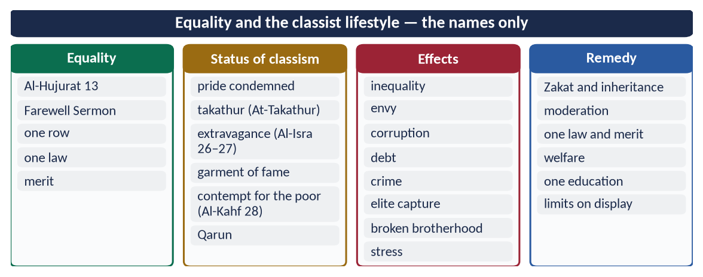
Figure 12 · At a glance — equality and the classist lifestyle — the names only. The detail is in the sections above.

Chapter 8 · Social Justice
The full note is in Topic 4, Section 4.5; here, the essentials as a characteristic of the civilization.
✦ QURAN
﴿لَقَدۡ أَرۡسَلۡنَا رُسُلَنَا بِٱلۡبَيِّنَٰتِ وَأَنزَلۡنَا مَعَهُمُ ٱلۡكِتَٰبَ وَٱلۡمِيزَانَ لِيَقُومَ ٱلنَّاسُ بِٱلۡقِسۡطِۖ …﴾
“We sent Our messengers with clear proofs and sent down with them the Book and the Balance, so that people may uphold justice.” (Al-Hadid, Quran)
➜ Messengers were sent so that people may uphold justice — justice is the purpose of the whole prophetic mission.

✦ QURAN
﴿إِنَّ ٱللَّهَ يَأۡمُرُ بِٱلۡعَدۡلِ وَٱلۡإِحۡسَٰنِ وَإِيتَآيِٕ ذِي ٱلۡقُرۡبَىٰ وَيَنۡهَىٰ عَنِ ٱلۡفَحۡشَآءِ وَٱلۡمُنكَرِ وَٱلۡبَغۡيِۚ يَعِظُكُمۡ لَعَلَّكُمۡ تَذَكَّرُونَ﴾
“Indeed, Allah orders justice and good conduct and giving to relatives and forbids immorality and bad conduct and oppression. He admonishes you that perhaps you will be reminded.” (An-Nahl, Quran)
➜ Allah commands justice, excellence and giving to relatives, and forbids indecency, wrongdoing and oppression.

8.1 The pillars
- Equality before the law — the Makhzumi woman: 'if Fatimah stole…'.
- Circulation of wealth — Zakat, inheritance, ban on riba and hoarding (Al-Hashr 7).
- Right of the needy — 'a right for the one who asks and the deprived' (Adh-Dhariyat 19).
- Fair wages — 'before his sweat dries' (Ibn Majah).
- Accountable rulers and state welfare — Umar (RA) and Umar ibn Abd al-Aziz.
✦ SCHOLARLY VIEW
Dr M. Umer Chapra · Islam and the Economic Challenge (FPSC reading list)
Chapra argues that Islam aims at socio-economic justice and the fulfilment of the basic needs of all — goals that neither capitalism nor socialism achieved — through a moral filter on consumption, Zakat, the abolition of interest and a caring state.
➜ The economist of Islamic social justice.

Chapter 9 · The Moral Value System of Islam
Asked in 2019: 'Throw light in detail on the moral value system of Islam as a significant feature of Islamic civilization.'

9.1 Morality at the heart of the mission
✦ HADITH
إِنَّمَا بُعِثْتُ لِأُتَمِّمَ مَكَارِمَ الْأَخْلَاقِ
“I was sent only to perfect the noblest morals.” (Al-Bayhaqi and Ahmad)

✦ QURAN
﴿وَإِنَّكَ لَعَلَىٰ خُلُقٍ عَظِيمٖ﴾
“And indeed, you are of a great moral character.” (Al-Qalam, Quran)
➜ 'You are of a great moral character.'

9.2 The sources of Islamic morality
- The Quran — the moral law.
- The Sunnah — the moral model: 'his character was the Quran' (Muslim).
- Fitrah — the sound nature that recognises good (Ar-Rum 30).
- Conscience — 'sin is what wavers in your heart' (Muslim).

9.3 The features of the moral system
Feature | Meaning
Divine | Based on revelation — not on changing opinion or majority vote
Universal | The same for rich and poor, ruler and ruled, Muslim and non-Muslim
Permanent | Truth is always good; lying always evil
Comprehensive | Covers the individual, family, business, politics, war and the environment
Balanced | Between body and soul, world and Hereafter, rights and duties
Practical | Within human capacity (Al-Baqarah 286); demonstrated by the Prophet ﷺ
Accountability | Every act recorded and judged (Az-Zalzalah 7–8)
Intention and act | Both count — 'actions are by intentions' (Al-Bukhari and Muslim)

9.4 The moral code of the Quran — Surah Al-Isra (17:23–37)
# | Command
1 | Worship none but Allah; be good to parents — not even 'uff' (23–24)
2 | Give relatives, the poor and the traveller their right; do not squander (26–27)
3 | Be moderate — neither miserly nor extravagant (29)
4 | Do not kill your children for fear of poverty (31)
5 | Do not approach zina (32)
6 | Do not kill unjustly (33)
7 | Do not touch the orphan's property except to improve it (34)
8 | Fulfil every commitment (34)
9 | Give full measure and weigh with an even balance (35)
10 | Do not follow what you have no knowledge of (36)
11 | Do not walk on the earth with arrogance (37)

✦ QURAN
﴿وَقَضَىٰ رَبُّكَ أَلَّا تَعۡبُدُوٓاْ إِلَّآ إِيَّاهُ وَبِٱلۡوَٰلِدَيۡنِ إِحۡسَٰنًاۚ إِمَّا يَبۡلُغَنَّ عِندَكَ ٱلۡكِبَرَ أَحَدُهُمَآ أَوۡ كِلَاهُمَا فَلَا تَقُل لَّهُمَآ أُفّٖ وَلَا تَنۡهَرۡهُمَا وَقُل لَّهُمَا قَوۡلٗا كَرِيمٗا﴾
“Your Lord has decreed that you worship none but Him, and that you be good to parents. If one or both of them reach old age with you, do not say to them even 'uff', nor repel them, but speak to them a noble word.” (Al-Isra, Quran)
➜ Your Lord has decreed that you worship none but Him and be good to parents — the first commandment of the code.

9.5 The core moral values

(1) Truthfulness (sidq)
✦ HADITH
إِنَّ الصِّدْقَ يَهْدِي إِلَى الْبِرِّ، وَإِنَّ الْبِرَّ يَهْدِي إِلَى الْجَنَّةِ
“Truthfulness leads to righteousness, and righteousness leads to Paradise.” (Al-Bukhari and Muslim)

(2) Trustworthiness (amanah)
✦ QURAN
﴿إِنَّ ٱللَّهَ يَأۡمُرُكُمۡ أَن تُؤَدُّواْ ٱلۡأَمَٰنَٰتِ إِلَىٰٓ أَهۡلِهَا وَإِذَا حَكَمۡتُم بَيۡنَ ٱلنَّاسِ أَن تَحۡكُمُواْ بِٱلۡعَدۡلِۚ إِنَّ ٱللَّهَ نِعِمَّا يَعِظُكُم بِهِۦٓۗ إِنَّ ٱللَّهَ كَانَ سَمِيعَۢا بَصِيرٗا﴾
“Indeed, Allah commands you to render trusts to whom they are due and when you judge between people to judge with justice. Excellent is that which Allah instructs you. Indeed, Allah is ever Hearing and Seeing.” (An-Nisa, Quran)
➜ Allah commands you to render trusts to whom they are due and to judge with justice.

(3) Justice ('adl)
✦ QURAN
﴿… وَلَا يَجۡرِمَنَّكُمۡ شَنَـَٔانُ قَوۡمٍ عَلَىٰٓ أَلَّا تَعۡدِلُواْۚ ٱعۡدِلُواْ هُوَ أَقۡرَبُ لِلتَّقۡوَىٰۖ …﴾
“Do not let the hatred of a people lead you to be unjust. Be just; that is nearer to righteousness.” (Al-Ma'idah, Quran)
➜ Do not let hatred lead you to injustice — be just; that is nearer to taqwa.

(4) Keeping promises
✦ QURAN
﴿… وَأَوۡفُواْ بِٱلۡعَهۡدِۖ إِنَّ ٱلۡعَهۡدَ كَانَ مَسۡـُٔولٗا﴾
“And fulfil every commitment; indeed, the commitment will be questioned about.” (Al-Isra, Quran)
➜ 'Fulfil every commitment.'

(5) Modesty and chastity (haya')
'Modesty is a branch of faith' (Al-Bukhari and Muslim); lowering the gaze (An-Nur 30–31).

(6) Humility, patience, forgiveness, generosity
✦ QURAN
﴿وَعِبَادُ ٱلرَّحۡمَٰنِ ٱلَّذِينَ يَمۡشُونَ عَلَى ٱلۡأَرۡضِ هَوۡنٗا وَإِذَا خَاطَبَهُمُ ٱلۡجَٰهِلُونَ قَالُواْ سَلَٰمٗا﴾
“And the servants of the Most Merciful are those who walk upon the earth easily, and when the ignorant address them [harshly], they say [words of] peace.” (Al-Furqan, Quran)
➜ The servants of the Most Merciful walk on the earth humbly, and when the ignorant address them, they say 'Peace'.

(7) Social morals
Kindness to neighbours ('he is not a believer whose neighbour is not safe from his harm' — Al-Bukhari), respect for elders, mercy to the young, care of orphans, honesty in trade.
✦ HADITH
مَنْ غَشَّ فَلَيْسَ مِنِّي
“Whoever cheats is not one of us.” (Muslim)
➜ Business ethics in two words.

9.6 Islamic morality and secular ethics
Question | Secular ethics | Islamic ethics
Source | Reason, utility or social agreement | Revelation, confirmed by reason and fitrah
Standard | Relative — changes with society (relativism) | Fixed principles, flexible application
Motive | Utility (Bentham, Mill) or duty (Kant) | Pleasure of Allah, with duty and benefit
Sanction | Law and public opinion | Law, conscience and the Hereafter
Private life | Largely free of moral rules | Morality in private and public alike

Utilitarianism can justify harming a minority for the majority's benefit; Kant's duty has no answer to 'why be moral when no one sees?'. Islam's answer is Ihsan — 'He sees you'.

9.7 Morality as the life of civilization
✦ SCHOLARLY VIEW
Ibn Khaldun · Al-Muqaddimah
Ibn Khaldun observed that when rulers and people sink into luxury and injustice, their solidarity weakens and the dynasty falls — moral decay is the beginning of political decline.
➜ Civilizations die morally first.

✦ SCHOLARLY VIEW
Allama Muhammad Iqbal · Zarb-e-Kalim
Iqbal warned that a nation's rise depends on its character, not its wealth or numbers.
➜ Character is national power.

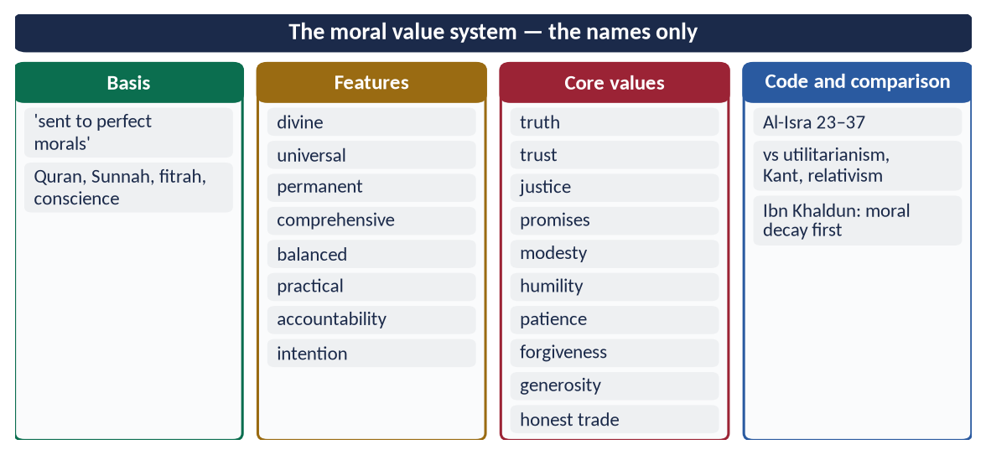
Figure 13 · At a glance — the moral value system — the names only. The detail is in the sections above.

Chapter 10 · Tolerance — in the Prophetic Age and in Muslim History
Asked in 2025: 'Discuss religious tolerance in the context of post-Prophetic Muslim history.' The Prophetic foundation is in Topic 3 (Chapters 3 and 8); this chapter carries it through fourteen centuries.

10.1 The meaning
Religious tolerance — tasamuh (تَسَامُح), Urdu rawadari — means allowing people of other faiths to live, worship and follow their own law in peace and dignity, while holding firmly to one's own belief.

10.2 The Quranic and Prophetic foundation
✦ QURAN
﴿لَآ إِكۡرَاهَ فِي ٱلدِّينِۖ قَد تَّبَيَّنَ ٱلرُّشۡدُ مِنَ ٱلۡغَيِّۚ …﴾
“There is no compulsion in religion; the right course has become clear from the wrong.” (Al-Baqarah, Quran)
➜ No compulsion in religion.

✦ QURAN
﴿لَكُمۡ دِينُكُمۡ وَلِيَ دِينِ﴾
“For you is your religion, and for me is my religion.” (Al-Kafirun, Quran)
➜ 'For you your religion, and for me mine.'

✦ QURAN
﴿لَّا يَنۡهَىٰكُمُ ٱللَّهُ عَنِ ٱلَّذِينَ لَمۡ يُقَٰتِلُوكُمۡ فِي ٱلدِّينِ وَلَمۡ يُخۡرِجُوكُم مِّن دِيَٰرِكُمۡ أَن تَبَرُّوهُمۡ وَتُقۡسِطُوٓاْ إِلَيۡهِمۡۚ إِنَّ ٱللَّهَ يُحِبُّ ٱلۡمُقۡسِطِينَ﴾
“Allah does not forbid you from those who do not fight you because of religion and do not expel you from your homes - from being righteous toward them and acting justly toward them. Indeed, Allah loves those who act justly.” (Al-Mumtahanah, Quran)
➜ Allah does not forbid kindness and justice to those who do not fight you.

✦ QURAN
﴿… وَلَوۡلَا دَفۡعُ ٱللَّهِ ٱلنَّاسَ بَعۡضَهُم بِبَعۡضٖ لَّهُدِّمَتۡ صَوَٰمِعُ وَبِيَعٞ وَصَلَوَٰتٞ وَمَسَٰجِدُ يُذۡكَرُ فِيهَا ٱسۡمُ ٱللَّهِ كَثِيرٗاۗ …﴾
“Were it not that Allah checks some people by means of others, monasteries, churches, synagogues and mosques — in which Allah's name is much mentioned — would have been demolished.” (Al-Hajj, Quran)
➜ Monasteries, churches, synagogues and mosques are protected alike.

✦ HADITH
أَلَا مَنْ ظَلَمَ مُعَاهَدًا، أَوِ انْتَقَصَهُ، أَوْ كَلَّفَهُ فَوْقَ طَاقَتِهِ، أَوْ أَخَذَ مِنْهُ شَيْئًا بِغَيْرِ طِيبِ نَفْسٍ، فَأَنَا حَجِيجُهُ يَوْمَ الْقِيَامَةِ
“Whoever wrongs a non-Muslim under covenant, belittles him, burdens him beyond his strength, or takes anything from him without his consent — I will argue against him on the Day of Resurrection.” (Abu Dawud)

The Prophetic model: the Charter of Madinah ('to the Jews their religion'), the Najran treaty (churches protected), the Christians of Najran praying in the Mosque of Madinah.

10.3 Tolerance in post-Prophetic Muslim history
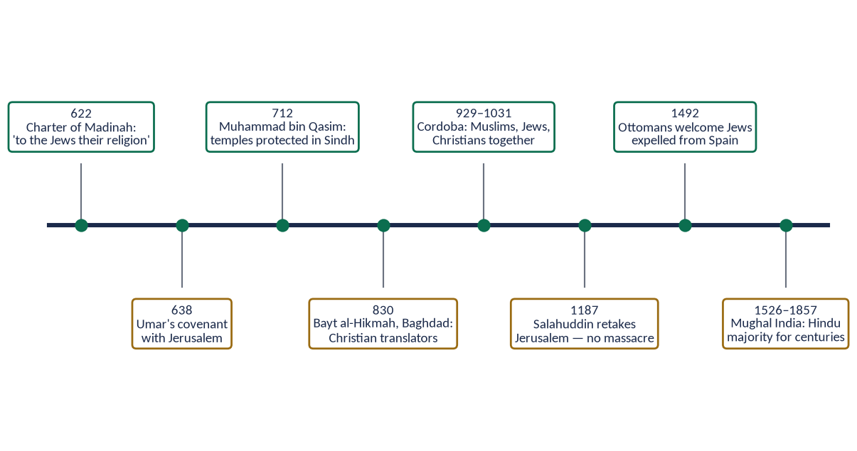
Figure 14 · Religious tolerance from the Charter of Madinah to Mughal India.

(1) The Rightly-Guided Caliphs
- Abu Bakr (RA) — his orders to the army: do not harm monks in their cells (Muwatta).
- Umar (RA) and Jerusalem (638) — his covenant with the people of Aelia guaranteed 'their lives, their property, their churches and their crosses … their churches shall not be occupied or demolished … they shall not be compelled in their religion' (Al-Tabari). Invited by Patriarch Sophronius to pray in the Church of the Holy Sepulchre, he prayed outside, so that Muslims would not later claim the church.
- Umar (RA) gave a poor old Jew a stipend from the treasury and exempted him from jizyah (Abu Yusuf, Kitab al-Kharaj).
- Ali (RA), as Caliph, lost his case over a shield to a non-Muslim before Qadi Shurayh.
✦ SCHOLARLY VIEW
Imam Abu Yusuf · Kitab al-Kharaj (to Caliph Harun al-Rashid)
The chief justice advised the Caliph to treat the dhimmis with gentleness, not to tax them beyond their means, and to protect their lives and property as the Prophet ﷺ and the Caliphs had done.
➜ Tolerance written into state policy.

(2) The Umayyads and the conquest of Sindh
Muhammad bin Qasim (712) treated Hindus and Buddhists as protected people; temples were left in their hands and Brahmins kept their positions (Chachnama).

(3) The Abbasids — Baghdad
The Bayt al-Hikmah employed Christian, Jewish and Sabian scholars — Hunayn ibn Ishaq, a Nestorian Christian, led the translation of Greek science; Christian physicians served the Caliphs.

(4) Muslim Spain — Cordoba (929–1031)
Under the Umayyad Caliphate of Cordoba, Muslims, Jews and Christians lived and worked together. Hasdai ibn Shaprut, a Jew, was physician and minister of Caliph Abd al-Rahman III. The Jewish scholar Maimonides later served as court physician in Egypt in the time of Salahuddin.

(5) Salahuddin and Jerusalem (1187)
When the Crusaders took Jerusalem in 1099, they massacred its Muslim and Jewish inhabitants. When Salahuddin Ayyubi retook it in 1187, he allowed the Christians to leave safely on payment of a ransom, freed many who could not pay, and left the Church of the Holy Sepulchre open.

(6) The Ottomans
The millet system gave each religious community its own leaders, law and schools. When Spain expelled its Jews in 1492, Sultan Bayezid II welcomed them into the empire.

(7) Muslim rule in the subcontinent
Muslims ruled much of India for centuries, yet the majority remained Hindu — clear evidence that Islam was not imposed by force. Hindus served as ministers and generals (for example Raja Todar Mal, Akbar's finance minister).

(8) Pakistan
✦ SCHOLARLY VIEW
Quaid-e-Azam Muhammad Ali Jinnah · Address to the Constituent Assembly, 11 August 1947
Jinnah declared that the people of Pakistan are free to go to their temples, mosques or any other places of worship, and that their religion, caste or creed has nothing to do with the business of the State.
➜ The founder's promise of equal citizenship.

Constitution: Article 20 (freedom of religion), Article 36 (protection of minorities); reserved seats for minorities.
Period | Example | Point
Prophet ﷺ | Charter; Najran | Religious freedom by covenant
Rashidun | Umar and Jerusalem (638) | Churches guaranteed; prayer outside the church
Umayyad | Sindh (712); Cordoba | Temples protected; Jews in high office
Abbasid | Bayt al-Hikmah | Christian and Jewish scholars honoured
Ayyubid | Salahuddin (1187) | No massacre in Jerusalem
Ottoman | Millet system; 1492 | Communities self-governed; refuge for Jews
Mughal | Hindu ministers; Hindu majority | No forced conversion

10.4 Honest limits
Muslim history also had periods of discrimination and conflict, and today sectarian violence and attacks on minorities occur in Muslim countries. These are departures from Islam, not examples of it; the examiner rewards an answer that admits them and measures them against the Quran and Sunnah.
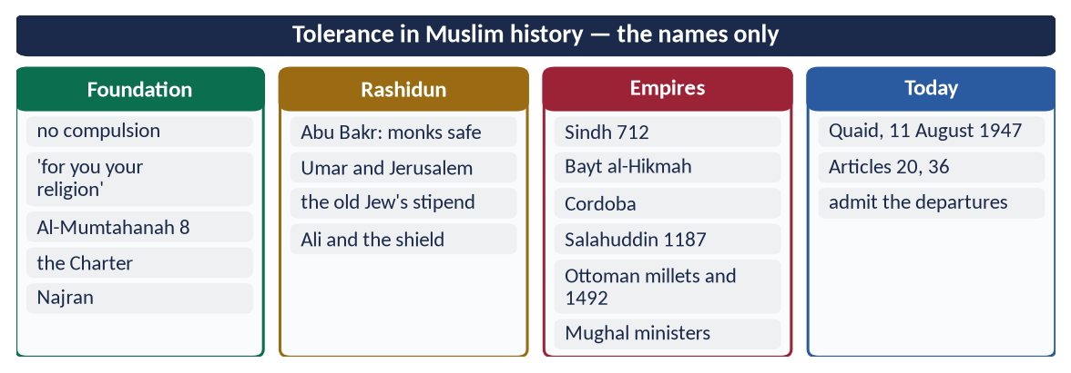
Figure 15 · At a glance — tolerance in Muslim history — the names only. The detail is in the sections above.

Chapter 11 · The Rule of Law
In the syllabus, never asked — a likely question.

11.1 The meaning
Rule of law — siyadat al-qanun (سِيَادَةُ الْقَانُون) — means that everyone, including the ruler, is subject to the same law, that law is known and applied equally, and that power is exercised through law, not whim.

11.2 The Quranic basis
✦ QURAN
﴿إِنَّ ٱللَّهَ يَأۡمُرُكُمۡ أَن تُؤَدُّواْ ٱلۡأَمَٰنَٰتِ إِلَىٰٓ أَهۡلِهَا وَإِذَا حَكَمۡتُم بَيۡنَ ٱلنَّاسِ أَن تَحۡكُمُواْ بِٱلۡعَدۡلِۚ إِنَّ ٱللَّهَ نِعِمَّا يَعِظُكُم بِهِۦٓۗ إِنَّ ٱللَّهَ كَانَ سَمِيعَۢا بَصِيرٗا﴾
“Indeed, Allah commands you to render trusts to whom they are due and when you judge between people to judge with justice. Excellent is that which Allah instructs you. Indeed, Allah is ever Hearing and Seeing.” (An-Nisa, Quran)
➜ Render trusts to whom they are due, and when you judge between people, judge with justice.

✦ QURAN
﴿يَـٰٓأَيُّهَا ٱلَّذِينَ ءَامَنُواْ كُونُواْ قَوَّـٰمِينَ بِٱلۡقِسۡطِ شُهَدَآءَ لِلَّهِ وَلَوۡ عَلَىٰٓ أَنفُسِكُمۡ أَوِ ٱلۡوَٰلِدَيۡنِ وَٱلۡأَقۡرَبِينَۚ …﴾
“O you who believe, stand firmly for justice, as witnesses for Allah, even if it be against yourselves, your parents or your relatives.” (An-Nisa, Quran)
➜ Stand firm for justice as witnesses for Allah, even against yourselves, your parents and relatives, rich or poor.

✦ QURAN
﴿… وَلَا يَجۡرِمَنَّكُمۡ شَنَـَٔانُ قَوۡمٍ عَلَىٰٓ أَلَّا تَعۡدِلُواْۚ ٱعۡدِلُواْ هُوَ أَقۡرَبُ لِلتَّقۡوَىٰۖ …﴾
“Do not let the hatred of a people lead you to be unjust. Be just; that is nearer to righteousness.” (Al-Ma'idah, Quran)
➜ Do not let hatred of a people lead you to injustice.

✦ QURAN
﴿يَٰدَاوُۥدُ إِنَّا جَعَلۡنَٰكَ خَلِيفَةٗ فِي ٱلۡأَرۡضِ فَٱحۡكُم بَيۡنَ ٱلنَّاسِ بِٱلۡحَقِّ وَلَا تَتَّبِعِ ٱلۡهَوَىٰ فَيُضِلَّكَ عَن سَبِيلِ ٱللَّهِۚ …﴾
“O Dawud, We have made you a vicegerent on the earth, so judge between people in truth and do not follow desire, lest it lead you astray from the way of Allah.” (Sad, Quran)
➜ 'O Dawud, We have made you a vicegerent on earth, so judge between people in truth and do not follow desire' — even a prophet-king is bound by law.

✦ QURAN
﴿… أَطِيعُواْ ٱللَّهَ وَأَطِيعُواْ ٱلرَّسُولَ وَأُوْلِي ٱلۡأَمۡرِ مِنكُمۡۖ فَإِن تَنَٰزَعۡتُمۡ فِي شَيۡءٖ فَرُدُّوهُ إِلَى ٱللَّهِ وَٱلرَّسُولِ …﴾
“Obey Allah and obey the Messenger and those in authority among you; and if you disagree over anything, refer it to Allah and the Messenger.” (An-Nisa, Quran)
➜ Obey Allah, the Messenger and those in authority; refer disputes to Allah and the Messenger — law above the ruler.

11.3 The Prophetic example
✦ HADITH
إِنَّمَا أَهْلَكَ الَّذِينَ قَبْلَكُمْ أَنَّهُمْ كَانُوا إِذَا سَرَقَ فِيهِمُ الشَّرِيفُ تَرَكُوهُ، وَإِذَا سَرَقَ فِيهِمُ الضَّعِيفُ أَقَامُوا عَلَيْهِ الْحَدَّ، وَايْمُ اللَّهِ لَوْ أَنَّ فَاطِمَةَ بِنْتَ مُحَمَّدٍ سَرَقَتْ لَقَطَعْتُ يَدَهَا
“Those before you were destroyed because when a noble among them stole they left him, and when a weak one stole they punished him. By Allah, if Fatimah daughter of Muhammad stole, I would cut off her hand.” (Al-Bukhari and Muslim)
➜ The same law for the noble and the weak.

- He offered Sawad ibn Ghaziyyah (RA) retaliation against himself at Badr.
- In his last illness he announced: whoever he had wronged may take his right from him (Ibn Hisham).
- He warned judges: 'I am only a human; if I judge for someone what is his brother's right, I am giving him a piece of the Fire' (Al-Bukhari and Muslim) — the judgement follows evidence.

11.4 The Rightly-Guided Caliphs — rulers under law
- Abu Bakr (RA), in his first address: 'Obey me as long as I obey Allah and His Messenger; if I disobey, you owe me no obedience. The weak among you is strong with me until I take his right for him; the strong is weak with me until I take from him what he owes' (Ibn Hisham).
- Umar (RA) — a Ghassanid prince, Jabalah ibn al-Ayham, struck a Bedouin during Tawaf; Umar ordered that the Bedouin be allowed retaliation, saying Islam had made them equal.
- Umar (RA) and the governor's son in Egypt: 'Since when have you enslaved people whose mothers bore them free?'
- Ali (RA) stood before Qadi Shurayh as a litigant and lost for lack of proper witnesses.

11.5 Institutions of the rule of law in Muslim history
- The qadi — an independent judge; Umar (RA) separated the judiciary from the governors.
- Qadi al-Qudat — the chief justice; Imam Abu Yusuf was the first to hold the title under Harun al-Rashid.
- Diwan al-Mazalim — a court of grievances against officials.
- Hisbah — the office of the market inspector (muhtasib).
- Mufti and fiqh — written, known law, developed by independent scholars such as Imam Abu Hanifah, who refused the post of chief justice rather than serve an unjust ruler.

11.6 Rule of law in Pakistan
- Constitution: Article 4 — the right of every citizen to be dealt with in accordance with law; Article 25 — equality before law; Article 10-A — fair trial.
- The gap: the World Justice Project Rule of Law Index 2024 ranked Pakistan 129th of 142 countries; VIP culture, delayed justice and selective accountability weaken the law.
Problem | Islamic remedy
Two laws — for the powerful and the weak | 'If Fatimah stole…'
Delay in justice | Quick, accessible qadi courts
Corruption of officials | Accountability of rulers; Umar's audits of governors
Political interference in courts | Independent qadi; Abu Hanifah's refusal
Custom above law (jirgas, honour killing) | The Shari'ah and the courts above tribe

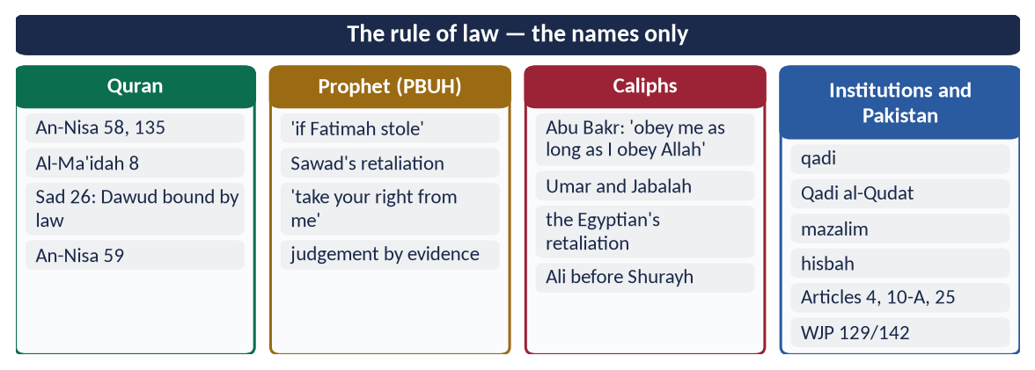
Figure 16 · At a glance — the rule of law — the names only. The detail is in the sections above.

Part Two — Contemporary Challenges, Narratives and Hot Debates

12.1 Materialism, consumerism and status competition
Advertising, social media and easy credit have turned consumption into identity: people are judged by brands, cars and weddings. The Quran names this disease — takathur, 'competition in increase' (At-Takathur 1–2) — and its cure — contentment ('true richness is richness of the soul', Al-Bukhari and Muslim), moderation (Al-Furqan 67) and spending on others. Pakistan's wedding extravagance, 'VIP culture' and debt-financed lifestyles are its local face.

12.2 Moral decline, corruption and the loss of trust
Pakistan ranked 135th of 180 in Transparency International's Corruption Perceptions Index 2024; adulteration, tax evasion and exam cheating are common. Laws and anti-corruption bodies (NAB, FIA) punish after the event; Islam adds tazkiyah — the inner police that works when no one is watching ('He sees you' — the hadith of Jibril).

12.3 Sufism: true teaching and the deviations of shrine culture
Sufism's message of love, service and tolerance is a powerful answer to extremism; its deviations — grave-worship, fake pirs, drugs and commercialism — are rejected by the great Sufis themselves. The balanced answer: reform shrines into centres of Quran, welfare and education under the Auqaf, and keep Sufism bound to the Shari'ah (Sirhindi, Shah Waliullah).

12.4 Digital ethics — social media, privacy, backbiting and fake news
Surah Al-Hujurat reads like a code for social media: verify news before spreading it (49:6); do not mock or insult (49:11); avoid suspicion, spying and backbiting (49:12). 'It is enough of a lie for a man to repeat everything he hears' (Muslim). Pakistan's Prevention of Electronic Crimes Act 2016 addresses the legal side; the moral side is tazkiyah of the tongue — and the thumb.

12.5 Tolerance in a polarised society
Sectarian hatred, political polarisation and mob violence threaten social peace. Islamic history offers the model of Umar and Jerusalem, Cordoba and the Ottoman millets; the Constitution offers Articles 20 and 36; the Quran offers 'no compulsion' and 'argue in the best way' (An-Nahl 125). The Paigham-e-Pakistan declaration (2018), endorsed by scholars of all schools, rejects violence in the name of religion.
DEBATE · IS ISLAMIC CIVILIZATION A THING OF THE PAST?
The critic says: its golden age ended centuries ago. The answer: a civilization is its values, not only its monuments; the values that built Baghdad and Cordoba — Tawhid, knowledge, justice, tolerance, tazkiyah — can rebuild it. Iqbal's call was to revive the spirit, not to copy the past.

Part Three — The Examiner's Record and Five Likely Questions

13.1 Every question on this topic, 2016–2025
Year | Question | Ch.
2016 Q2 | What is meant by culture and civilization? Describe the characteristics of Islamic culture. | 1
2017 Q6 | Explain the concept of self-purification in the light of the Qur'ān and Sunnah and its impact on society. | 4
2018 Q3 | What is Self-purification and Ehsan? Explain it in the light of Quran and Sunnah, also describe its individual and collective impacts. | 4
2018 Q7 | Describe, in detail, the basic characteristics of Islamic civilization. | 1, 3–11
2019 Q5 | Throw light in detail on the moral value system of Islam as a significant feature of Islamic civilization. | 9
2021 Q7 | Explore the importance of Sufism to spread out Islam. Is the amelioration of current deviation possible through Sufism? | 5
2024 Q2 | Self-purification is an essential element for the evolution of society. Explain. | 4
2025 Q4 | Determine the status of the classist lifestyle in the light of the teachings of Islam and examine its effects on human society. | 7
2025 Q7 | Discuss religious tolerance in the context of post-Prophetic Muslim history. | 10

All nine are answered in T5QA. Related questions set under other topics: dignity irrespective of colour and creed (2020 — Topic 4), social justice (2023 note — Topic 4), co-existence in a multi-faith society (2021) and Western influence on Islamic civilization (2026) — Topic 6.

13.2 What the record teaches
- Tazkiyah four times (with Sufism) — the single most-repeated idea of this topic.
- Characteristics twice (2016, 2018) — learn the tree and the full table.
- Since 2025, each of the eight characteristics can become a whole question.
- Never asked: the role of civilization in personality and community; rule of law; the vital elements on their own.

13.3 Five likely questions
1. What are the vital elements of a civilization? Explain the role of Islamic civilization in the development of human personality and community.
2. Rule of law is the hallmark of Islamic civilization. Discuss with examples from the Prophetic and Rashidun eras.
3. Tawhid is the foundation of Islamic civilization. Explain its impact on the individual and society.
4. Explain the moral system of Islam and its superiority over secular ethics.
5. Discuss the contribution of the Sufis to the spread of Islam in the subcontinent.

Part Four — The One-Liner Bank

One-liners · Culture and civilization
1. 'Culture' comes from Latin cultura — cultivation.
2. 'Civilization' comes from Latin civis / civitas — citizen, city.
3. Arabic words for culture: thaqafah; Urdu: tehzeeb (pruning).
4. Arabic words for civilization: hadarah (settled life) and tamaddun (from madinah).
5. Ibn Khaldun's word for civilization: 'umran; for group solidarity: 'asabiyyah.
6. Al-Muqaddimah was completed in 1377 by Ibn Khaldun.
7. Classic definition of culture ('that complex whole…'): E. B. Tylor, Primitive Culture, 1871.
8. 'Civilization is social order promoting cultural creation': Will Durant.
9. Durant's four elements: economic provision, political organization, moral traditions, knowledge and the arts.
10. Culture is the inner side; civilization the outer side.
11. The Prophet ﷺ renamed Yathrib Madinah — 'the city'.
12. 'He settled you in the earth' (ista'marakum) — Hud 61.
13. Min Rawa'i Hadaratina (on the FPSC list): Dr Mustafa al-Siba'i.
14. Al-Qarawiyyin, Fez, was founded in 859 by Fatima al-Fihri.
15. Al-Azhar, Cairo, was founded in 970.
16. Algebra (al-jabr) and the word 'algorithm': Al-Khwarizmi.
17. Al-Qanun fi al-Tibb: Ibn Sina; Kitab al-Manazir: Ibn al-Haytham.
18. Kitab al-Hind and the earth's radius: Al-Biruni.
19. First paper mill in Baghdad: about 794.
20. The Quaid's letter listing Muslim culture and civilization: to Gandhi, September 1944.
21. Iqbal's ideal personality: mard-e-momin.

One-liners · Tawhid
22. Iqbal: Tawhid as a working idea is equality, solidarity and freedom.
23. Al-Tawhid: Its Implications for Thought and Life (1982): Isma'il al-Faruqi.
24. 'Do not take one another as lords besides Allah' — Aal-e-Imran 64.
25. Signs in the heavens and earth 'for people of understanding' — Aal-e-Imran 190.
26. Islamic art, avoiding images of the divine, developed calligraphy, geometry and the arabesque.
27. The parable of the good tree — Ibrahim 24–25.

One-liners · Tazkiyah and Ihsan
28. Tazkiyah means purification and growth.
29. 'He has succeeded who purifies it' — Ash-Shams 9.
30. 'He has succeeded who purifies himself' — Al-A'la 14.
31. The Prophet's four functions include yuzakkihim — Al-Jumu'ah 2.
32. 'Except one who comes with a sound heart' — Ash-Shu'ara 89.
33. Nafs ammarah — Yusuf 53; lawwamah — Al-Qiyamah 2; mutma'innah — Al-Fajr 27.
34. 'In the body is a piece of flesh … it is the heart' — Al-Bukhari and Muslim.
35. Ihsan: worship Allah as though you see Him — the hadith of Jibril (Muslim).
36. 'The true mujahid strives against his own self' — Al-Tirmidhi.
37. 'Take account of yourselves before you are taken to account' — Umar (RA).
38. 'In the remembrance of Allah hearts find rest' — Ar-Ra'd 28.
39. 'Be with the truthful' — At-Tawbah 119.
40. Riya' is called the minor shirk — Ahmad.
41. 'Modesty is a branch of faith' — Al-Bukhari and Muslim.
42. The four quarters of the Ihya': worship, customs, destroyers (muhlikat), saviours (munjiyat).
43. 'Allah does not change a people until they change what is in themselves' — Ar-Ra'd 11.
44. Pakistan in the Corruption Perceptions Index 2024: 135th of 180.
45. The three levels in the hadith of Jibril: Islam, Iman, Ihsan.
46. 'Allah has prescribed ihsan in everything' — Muslim.
47. 'Allah loves the muhsinin (doers of good)' — Al-Baqarah 195.

One-liners · Sufism
48. Possible roots of 'Sufi': suf (wool), safa' (purity), Ahl al-Suffah.
49. Al-Risalah on Sufism within the Shari'ah: Imam al-Qushayri.
50. Worship out of pure love of Allah: Rabi'ah al-Adawiyyah.
51. 'Sober' Sufism bound by the Shari'ah: Junayd al-Baghdadi.
52. Founder of the Qadiri order: Shaykh Abd al-Qadir Jilani (d. 561 AH).
53. Kashf al-Mahjub — first Persian treatise on Sufism: Ali Hujwiri (Data Ganj Bakhsh), Lahore.
54. Founder of the Chishti order in India: Khwaja Mu'in al-Din Chishti, Ajmer (d. 1236).
55. The Suhrawardi saint of Multan: Bahauddin Zakariya (d. 1262).
56. Baba Farid Ganj Shakar is buried at Pakpattan.
57. Lal Shahbaz Qalandar is buried at Sehwan.
58. Mujaddid Alf Thani: Shaykh Ahmad Sirhindi (Naqshbandi, d. 1624).
59. Sirhindi opposed Akbar's Din-i-Ilahi.
60. Shah jo Risalo: Shah Abdul Latif Bhittai.
61. The Preaching of Islam (1896): Sir Thomas Arnold.
62. The free kitchen of the Sufis: langar.
63. Major shrines were taken over by the Auqaf department in 1960–61.
64. Punjabi Sufi poet of Kasur: Bulleh Shah; Pashto Sufi poet: Rahman Baba.
65. The soul's inborn sense of good: fitrah — Ar-Rum 30.

One-liners · Dignity, equality and social justice
66. 'We have honoured the children of Adam' — Al-Isra 70.
67. 'Competition in increase distracts you' — At-Takathur 1.
68. 'The squanderers are brothers of the devils' — Al-Isra 27.
69. Neither extravagant nor miserly — Al-Furqan 67.
70. 'True richness is richness of the soul' — Al-Bukhari and Muslim.
71. 'Look at those below you' — Muslim.
72. 'Whoever wears a garment of fame…' — Abu Dawud.
73. Pride = rejecting the truth and looking down on people — Muslim.
74. Some raised above others in degrees to test you — Al-An'am 165.
75. The man of wealth swallowed by the earth: Qarun — Al-Qasas.
76. 'Mahmood-o-Ayaz' in one row: Iqbal, Shikwa.
77. Elite privilege in Pakistan: about 17.4 billion dollars a year (UNDP NHDR, 2021).
78. Messengers sent so that people uphold justice — Al-Hadid 25.
79. Islam and the Economic Challenge: Dr M. Umer Chapra.
80. Umar (RA) entered Jerusalem in patched clothes, walking in turn with his servant.
81. 'Verify news before spreading it' — Al-Hujurat 6.
82. Pakistan's cyber-crime law: PECA, 2016.

One-liners · Moral values
83. 'I was sent to perfect the noblest morals' — Al-Bayhaqi and Ahmad.
84. 'Righteousness is good character' — Muslim.
85. The Quranic moral code: Al-Isra 23–37.
86. 'Whoever cheats is not one of us' — Muslim.
87. 'Truthfulness leads to righteousness' — Al-Bukhari and Muslim.
88. The servants of the Most Merciful walk humbly — Al-Furqan 63.
89. Utilitarianism: Bentham and Mill; duty ethics: Kant.
90. An-Nahl 90 commands both 'adl (justice) and ihsan (excellence).

One-liners · Tolerance
91. Umar's covenant with Jerusalem: 638.
92. The Patriarch of Jerusalem who received Umar: Sophronius.
93. Umar prayed outside the Church of the Holy Sepulchre.
94. Muhammad bin Qasim conquered Sindh in 712.
95. The Christian translator who led the Bayt al-Hikmah: Hunayn ibn Ishaq.
96. Jewish minister of Abd al-Rahman III: Hasdai ibn Shaprut.
97. Crusaders' massacre in Jerusalem: 1099; Salahuddin's peaceful recovery: 1187.
98. The Ottoman system of self-governing religious communities: the millet system.
99. Sultan who welcomed the Jews expelled from Spain in 1492: Bayezid II.
100. Hindu finance minister of Akbar: Raja Todar Mal.
101. The Quaid's speech on equal citizenship: 11 August 1947.
102. Paigham-e-Pakistan declaration against violence: 2018.

One-liners · Rule of law
103. 'Judge between people in truth' — said to Prophet Dawud, Sad 26.
104. 'Those before you were destroyed because they spared the noble…' — Al-Bukhari and Muslim.
105. The Ghassanid prince made to face retaliation by Umar: Jabalah ibn al-Ayham.
106. The judge before whom Ali (RA) lost his case: Qadi Shurayh.
107. The first Qadi al-Qudat (chief justice): Imam Abu Yusuf.
108. The court of grievances against officials: Diwan al-Mazalim.
109. The market inspector: muhtasib (office of hisbah).
110. The Imam who refused the post of chief justice: Abu Hanifah.
111. Right to be dealt with according to law: Article 4; fair trial: Article 10-A.
112. Pakistan in the WJP Rule of Law Index 2024: 129th of 142.
113. Abu Bakr's first address: 'Obey me as long as I obey Allah and His Messenger'.
114. The Punjab law limiting wedding extravagance: Marriage Functions Act, 2016.
ONE-LINER COUNT
This topic carries 114 one-liners, numbered 1–114. Revise them in blocks of twenty; tick the ones you can answer without looking.

Part Five — Revision Notes · Topic 5
Read these on the night before the paper. Every chapter is broken into its sections; each section gives the chain of ideas, the evidence to quote, and the names and numbers to remember. The last line of each chapter tells you which question it serves.

R5.0 The whole topic in one picture
- The tree: root Tawhid → trunk Tazkiyah → six branches: dignity, equality, social justice, moral values, tolerance, rule of law → fruit: a just, learned, humane civilization (Ibrahim 24).
- The two words: culture = the inner way of life (beliefs, values, manners); civilization = the outer achievement (institutions, cities, sciences). In Islam the inner produces the outer.
- The favourite question: tazkiyah (2017, 2018, 2024) and Sufism (2021) — four of nine questions.
- The new trend: since 2025 each characteristic can be a full question (equality → classist lifestyle; tolerance → post-Prophetic history).

R5.1 Chapter 1 · Culture and civilization: meanings and elements

1.1–1.2 The meanings
- Culture: Latin cultura (tilling the soil → tilling the mind) → Arabic thaqafah (straightening a spear → refining a person) → Urdu tehzeeb (pruning a tree).
- Definition: Tylor (1871) — 'that complex whole: knowledge, belief, art, morals, law, custom … acquired as a member of society'.
- Simple: the way of life of a people.
- Civilization: Latin civis/civitas (citizen, city) → Arabic hadarah (settled life, opposite of badawah) and tamaddun (from madinah).
- Durant: 'social order promoting cultural creation' — four elements: economy, polity, morals, knowledge and arts.
- Ibn Khaldun (1377): 'umran; badawah → hadarah; held together by 'asabiyyah; destroyed by luxury and moral decay within a few generations.
- The Prophet ﷺ renamed Yathrib Madinah — Islamic civilization began as a city.

1.3 The difference
- Culture: inner · what we are · hard to borrow · changes slowly · e.g. modesty, hospitality.
- Civilization: outer · what we have · easy to borrow · changes fast · e.g. roads, universities, courts.
- Islam: one flows from the other; Iqbal — take the West's science, not its loss of spirit.

1.4 The vital elements (draw the wheel)
- Centre: worldview (God, man, life, death).
- Around it: values and morals → knowledge → language and literature → family and institutions → economy → politics and law → art and architecture → customs, dress, food, festivals → science and technology.

1.5 The Islamic view
- Man = khalifah (Al-Baqarah 30) → civilization = building the earth as a trust (ista'marakum, Hud 61) → balance of world and Hereafter (Al-Qasas 77).

1.6 The characteristics (the 2016 and 2018 list)
- Faith: Tawhid · Prophethood · accountability · tazkiyah.
- Person: dignity · knowledge ('Read!') · cleanliness ('half of faith') · dignity of labour.
- Society: equality · social justice · brotherhood (Al-Hujurat 10) · family · tolerance.
- State and style: rule of law · balance (wasatiyyah, Al-Baqarah 143) · universality · moral values · art without idols.
- Scholar: Mustafa al-Siba'i (Min Rawa'i Hadaratina, FPSC list) — monotheism, universal aim, morality in every field, knowledge, unmatched tolerance.
- Exam use: 2016 → meanings (1.1–1.3) + characteristics (1.6); 2018 → the tree + one heading per characteristic (Ch. 3–11). Open with Tylor or Durant; close with the tree verse (Ibrahim 24).

R5.2 Chapter 2 · Role of civilization in personality and community

2.1 Personality
- Identity → 'Who am I?': a servant of Allah, a member of the Ummah.
- Conscience → 'righteousness is good character; sin is what wavers in your heart' (Muslim).
- Discipline → five prayers, fasting, cleanliness, the adab of daily life.
- Purpose → 'I created jinn and mankind only to worship Me' (Adh-Dhariyat 56).
- Ideal → Iqbal's mard-e-momin: faith + knowledge + courage + humility + action.

2.2 Community
- Brotherhood → 'the believers are brothers' (Al-Hujurat 10).
- Institutions → mosque (school and council) · waqf (hospitals, schools, water) · madrasa and university (Qarawiyyin 859, Fatima al-Fihri; Al-Azhar 970) · bimaristan (free hospital).
- Common law (Shari'ah, the qadi) · welfare (Zakat, waqf) · shared memory (qiblah, Hijri calendar, Arabic, festivals).

2.3 Gifts to the world (names to drop)
- Al-Khwarizmi — algebra, 'algorithm' · Ibn Sina — Qanun · Ibn al-Haytham — optics, experiment · Al-Biruni — earth's radius, Kitab al-Hind · Ibn Rushd — Aristotle to Europe · Ibn Khaldun — sociology · paper mill in Baghdad (c. 794) · Cordoba's library (~400,000 volumes).

2.4 The Quaid
- Letter to Gandhi (Sept 1944): a nation with its own culture and civilization, language and literature, art and architecture, laws and moral code, customs and calendar.
- Exam use: the likely question on 'personality and community' → two main headings (2.1, 2.2) + historical proof (2.3) + Quaid (2.4).

R5.3 Chapter 3 · Tawhid — the foundation
- Meaning: Allah is One in Lordship, worship, names and attributes (Al-Ikhlas).
- Seven effects on civilization:
1. One God → one humanity → equality (Al-Hujurat 13); Iqbal: Tawhid = equality, solidarity, freedom.
2. Freedom from kings, priests, idols, superstition, desire → 'do not take one another as lords' (Aal-e-Imran 64).
3. Unity of knowledge and life → no sacred–secular split; scholar-physicians.
4. Freedom for science → nature is a sign, not a god (Aal-e-Imran 190).
5. Accountability → conscience, the inner police.
6. Unity of the Ummah → one God, Book, Prophet, qiblah.
7. Art → no images of God → calligraphy, geometry, arabesque (Dome of the Rock, Alhambra, Badshahi, Faisal Mosque).
- Scholar: al-Faruqi, Al-Tawhid (1982).
- Exam use: first heading of any 'characteristics' answer; possible full question on 'Tawhid as the foundation'.

R5.4 Chapter 4 · Tazkiyah and Ihsan (2017, 2018, 2024)

4.1 Meaning
- Tazkiyah = purification + growth (same root as Zakat) → cleansing the self of evil traits and growing good ones, to obey Allah willingly with a sound heart.

4.2 Quran — five proofs
- Success depends on it → Ash-Shams 7–10: 'he has succeeded who purifies it, failed who corrupts it'; Al-A'la 14.
- A purpose of Prophethood → Al-Jumu'ah 2: yuzakkihim.
- The sound heart on the Last Day → Ash-Shu'ara 88–89.
- Restraining desire → An-Nazi'at 40–41.
- Three stages (draw the ladder) → ammarah (Yusuf 53) → lawwamah (Al-Qiyamah 2) → mutma'innah (Al-Fajr 27–28).

4.3 Sunnah — three hadith
- The heart hadith → 'if it is sound, the whole body is sound' (Al-Bukhari and Muslim).
- Allah looks at hearts and deeds (Muslim).
- 'The mujahid strives against his own self' (Al-Tirmidhi).

4.4 Ihsan
- Hadith of Jibril → 'as though you see Him; if not, He sees you' (Muslim) → Islam (acts) · Iman (beliefs) · Ihsan (quality).
- Ihsan to people → 'Allah prescribed ihsan in everything' (Muslim) → An-Nahl 90: justice and excellence → Al-Baqarah 195.

4.5 The means (nine)
- Salah (Al-Ankabut 45) · Sawm (taqwa) · Zakat (At-Tawbah 103) · dhikr (Ar-Ra'd 28) · muhasabah (Umar: 'take account of yourselves') · tawbah · good company (At-Tawbah 119) · knowledge (Fatir 28) · remembering death.

4.6 Diseases and virtues
- Destroyers: pride (atom's weight — Muslim) · envy (eats good deeds — Abu Dawud) · riya' (minor shirk — Ahmad) · greed · anger · backbiting.
- Saviours: ikhlas · sabr · shukr · tawakkul · tawadu' · haya' ('a branch of faith') · qana'ah · love of Allah.
- Ghazali's *Ihya'*: four quarters → worship · customs · muhlikat · munjiyat.

4.7 Individual impacts
- Peace · integrity · self-control · moral excellence · mental health · success in both worlds.

4.8 Collective impacts and the evolution of society (draw the ripple)
- Law of change: Ar-Ra'd 11 — Allah does not change a people until they change themselves.
- Heart → family (rights, patience) → economy (no fraud, riba, hoarding) → governance (honest officials) → justice (truthful witnesses) → harmony (no envy, backbiting) → less crime → civilization (Ibn Khaldun: moral decay destroys).
- Proof: the Companions — Umar with flour at night; Abu Ubaydah's bare house; Al-Fath 29.
- Reformers: Umar ibn Abd al-Aziz · Ghazali · Sirhindi · Shah Waliullah — each began with the self.
- Pakistan: CPI 2024 → 135/180 → rituals without purification; the order is 'recite, purify, teach'.
- Exam use: 2017 → concept + impact on society; 2018 → add Ihsan and split impacts into individual/collective; 2024 → build around Ar-Ra'd 11 and the ripple, from individual to civilization.

R5.5 Chapter 5 · Sufism (2021)

5.1 Meaning
- Suf (wool) / safa' (purity) / Suffah → the discipline of the heart = tazkiyah and ihsan within the Shari'ah (Qushayri).

5.2 Early masters
- Hasan al-Basri (fear of Allah) → Rabi'ah (pure love) → Junayd (sober, Shari'ah-bound) → Ghazali (Ihya' joins Sufism and law) → Abd al-Qadir Jilani (Qadiri order).

5.3 The subcontinent (draw the timeline)
- Hujwiri, Lahore (d. c. 1072) — Kashf al-Mahjub (first Persian Sufi text).
- Chishti: Mu'in al-Din (Ajmer, 1236) → Baba Farid (Pakpattan) → Nizamuddin Auliya (Delhi).
- Suhrawardi: Bahauddin Zakariya (Multan, 1262) · Qalandar: Lal Shahbaz (Sehwan).
- Naqshbandi: Sirhindi, Mujaddid Alf Thani (1624) — against Akbar's Din-i-Ilahi.
- Poets: Sultan Bahu · Bulleh Shah · Shah Abdul Latif Bhittai (Shah jo Risalo) · Rahman Baba.
- How they spread Islam: character → langar equality against caste → service → local-language poetry → khanqah as school → no compulsion (An-Nahl 125).
- Evidence: T. W. Arnold, The Preaching of Islam (1896) — traders and Sufis, not the sword.

5.4 Deviations
- Prostration and petitions at graves · neglect of Salah · hereditary and fake pirs · commercialism · drugs, dance at 'urs · amulets for profit.
- Rule: criticise practices, not people; the great Sufis themselves rejected these.

5.5 Reform through Sufism — yes, if…
- Sufism = science of the heart; society's disease = disease of the heart.
- Shari'ah first (Sirhindi, Shah Waliullah) · love against extremism · langar against class pride · shrines reformed under Auqaf (1960–61) into centres of Quran, welfare, education.
- Conditions: sound knowledge · Shari'ah as the criterion · no commerce or politics · sincere, not hereditary, guides.
- Exam use: 2021 → two limbs: 'importance to spread Islam' (5.3) + 'is reform possible' (5.4–5.5) → answer 'yes, conditionally'.

R5.6 Chapter 6 · Dignity of man
- Honoured (Al-Isra 70) · best form (At-Tin 4) · spirit (Al-Hijr 29) · khalifah (Al-Baqarah 30).
- Protected: life, property, honour (Farewell Sermon); no mockery, spying, backbiting (Al-Hujurat 11–12).
- Shaped the civilization: end of infanticide and mutilation; freeing of slaves ('fi al-riqab'); dignity of labour; freed slaves as scholars (Ata, Nafi'); the mu'ahad protected; 'your servants are your brothers' (Al-Bukhari).
- Full treatment → Topic 4, Chapter 4.

R5.7 Chapter 7 · Equality and the classist lifestyle (2025)

7.1 Define
- Classist lifestyle = dividing and displaying division by wealth, status or birth → aristocracy, feudalism, caste → today consumerism and elite privilege.

7.2 Equality
- Al-Hujurat 13 · Farewell Sermon (no Arab over non-Arab…) · one row in Salah · two sheets in Hajj · 'if Fatimah stole' · Bilal, Salman, Usamah.

7.3 Wealth is a test, not a rank
- Az-Zukhruf 32 (degrees for mutual service) · Al-An'am 165 (degrees to test you).

7.4 Status in Islam — condemned on six counts
1. Pride → Luqman 18–19; 'atom's weight of pride' = rejecting truth + looking down on people (Muslim).
2. Display and competition → At-Takathur 1–2; Al-Hadid 20; Al-Humazah 1–3.
3. Extravagance → Al-Isra 26–27 (brothers of devils); Al-Furqan 67; 'eat, drink, dress, give — without extravagance or arrogance' (Ahmad, Nasa'i).
4. Status dress → 'garment of fame → garment of humiliation' (Abu Dawud).
5. Contempt for the poor → Al-Kahf 28; Al-An'am 52 (the Quraysh chiefs' demand refused).
6. Qarun → out in his adornment → swallowed by the earth (Al-Qasas 79–81).
- The alternative: 'richness of the soul' (Al-Bukhari and Muslim) · 'look below you' (Muslim) · the Prophet's mat · Umar in patched clothes at Jerusalem · Ali's coarse shirt · Iqbal: 'Mahmood-o-Ayaz'.

7.5 Effects on society (nine)
- Inequality · envy · corruption · debt · crime and unrest · elite capture · broken brotherhood · stress · merit replaced by sifarish.
- Pakistan: UNDP NHDR 2021 → elite privilege $17.4 bn ≈ 6% of GDP; weddings, VIP protocol, separate schools.

7.6 Remedy
- Zakat, inheritance (Al-Hashr 7) · moderation · one law and merit · welfare · one good education system · limits on display (Punjab Marriage Functions Act).
- Exam use: 2025 → 'status' (7.2–7.4) + 'effects' (7.5) + remedy (7.6).

R5.8 Chapter 8 · Social justice
- Purpose of prophethood → Al-Hadid 25; An-Nahl 90.
- Pillars → equality before law · circulation of wealth (Al-Hashr 7) · right of the needy (Adh-Dhariyat 19) · fair wages (Ibn Majah) · accountable rulers · welfare (Umar; Umar ibn Abd al-Aziz).
- Scholar → Umer Chapra, Islam and the Economic Challenge: basic needs, moral filter, Zakat, no interest.
- Full note → Topic 4, Section 4.5.

R5.9 Chapter 9 · The moral value system (2019)

9.1–9.2 Basis and sources
- 'Sent to perfect the noblest morals' → Al-Qalam 4 → sources: Quran · Sunnah ('his character was the Quran') · fitrah (Ar-Rum 30) · conscience ('what wavers in your heart').

9.3 Eight features
- Divine · universal · permanent · comprehensive · balanced · practical (Al-Baqarah 286) · accountability (Az-Zalzalah 7–8) · intention + act.

9.4 The code of Al-Isra (23–37) — eleven commands
- Tawhid and parents → rights of kin, poor, traveller; no squandering → moderation → no killing children → no zina → no unjust killing → orphan's property → keep commitments → full measure → no following without knowledge → no arrogance.

9.5 Core values
- Truth ('leads to righteousness → Paradise') · trust (An-Nisa 58) · justice (Al-Ma'idah 8) · promises (Al-Isra 34) · modesty · humility (Al-Furqan 63) · patience · forgiveness · generosity · social morals (neighbour) · business ('whoever cheats is not one of us' — Muslim).

9.6 Versus secular ethics
- Source: revelation vs reason/utility/agreement · standard: fixed vs relative · motive: Allah's pleasure vs utility (Bentham, Mill) or duty (Kant) · sanction: law + conscience + Hereafter vs law + opinion · private life: included vs mostly free.
- Key argument: utilitarianism can sacrifice a minority; Kant cannot answer 'why be moral unseen?' → Islam answers with Ihsan.

9.7 Morality and the life of civilizations
- Ibn Khaldun: luxury + injustice → weak 'asabiyyah → fall · Iqbal: a nation rises by character.
- Exam use: 2019 → basis → features → code → values → comparison → civilizational role.

R5.10 Chapter 10 · Tolerance in Muslim history (2025)
- Meaning: tasamuh / rawadari → others live, worship and keep their law in peace, while I hold my faith.
- Foundation: Al-Baqarah 256 · Al-Kafirun 6 · Al-Mumtahanah 8 · Al-Hajj 40 · 'I will argue against him' (Abu Dawud) · Charter · Najran.
- Post-Prophetic history (draw the timeline):
- Abu Bakr: do not harm monks.
- Umar, Jerusalem 638: covenant — lives, property, churches, crosses; no compulsion; prayed outside the Holy Sepulchre (Sophronius); stipend for the old Jew; Ali lost to a non-Muslim before Shurayh.
- Abu Yusuf (Kitab al-Kharaj): gentleness with dhimmis as state policy.
- Sindh 712: Muhammad bin Qasim — temples and Brahmins kept (Chachnama).
- Baghdad: Bayt al-Hikmah — Hunayn ibn Ishaq (Christian) led translation.
- Cordoba 929–1031: Hasdai ibn Shaprut (Jewish minister); Maimonides later physician in Egypt.
- Jerusalem 1187: Salahuddin — no massacre (contrast 1099).
- Ottomans: millet system; 1492 — Bayezid II welcomes Spain's Jews.
- Mughals: Hindu majority kept; Todar Mal.
- Pakistan: Quaid, 11 August 1947; Articles 20, 36.
- Honest limit: periods of discrimination and today's sectarian violence are departures from Islam.
- Exam use: 2025 → a short foundation, then chronological headings (Rashidun → Umayyad → Abbasid → Spain → Ayyubid → Ottoman → Mughal → Pakistan), with the table, ending with the honest limit.

R5.11 Chapter 11 · Rule of law
- Meaning: everyone, including the ruler, under the same known law.
- Quran: An-Nisa 58 (judge with justice) · An-Nisa 135 (even against yourselves and parents) · Al-Ma'idah 8 · Sad 26 (Dawud: judge in truth, not desire) · An-Nisa 59 (refer disputes to Allah and the Messenger).
- Prophet ﷺ: Makhzumi woman — 'nations destroyed for sparing the noble… if Fatimah stole' · retaliation offered to Sawad · 'whoever I wronged, take your right' · judgement by evidence ('a piece of the Fire').
- Caliphs: Abu Bakr's first address ('obey me as long as I obey Allah; the weak is strong with me…') · Umar and Jabalah ibn al-Ayham · Umar and the Egyptian ('born free') · Ali before Shurayh.
- Institutions: independent qadi · Qadi al-Qudat (Abu Yusuf) · Diwan al-Mazalim · hisbah (muhtasib) · fiqh as known law · Abu Hanifah refused the judgeship.
- Pakistan: Articles 4, 10-A, 25 · WJP 2024 129/142 · problems → two laws, delay, corruption, interference, jirgas → Islamic remedies.
- Exam use: the likely question → Quran → Prophet → Caliphs → institutions → Pakistan.

R5.12 Part Two · Today
- Consumerism → takathur → contentment, moderation.
- Corruption → CPI 135/180 → tazkiyah as the inner police.
- Shrine culture → reform under Auqaf, Shari'ah-bound Sufism.
- Digital ethics → Al-Hujurat 6, 11, 12; 'repeating all one hears is a lie' (Muslim); PECA 2016.
- Polarisation → Umar, Cordoba, millets; Articles 20, 36; Paigham-e-Pakistan (2018).
- Debate: is Islamic civilization past? → no: its values can rebuild it (Iqbal).

R5.13 The figures to draw in the paper
- The tree (Tawhid root, Tazkiyah trunk, six branches) — for any 'characteristics' answer.
- The elements wheel — for 'vital elements'.
- The nafs ladder and the ripple — for every tazkiyah answer.
- The Sufi timeline — for Sufism.
- The tolerance timeline — for 2025-type questions.

